**#31b: A 117 Emergency Communication Platform for Abuse Report in a Mobile Application**

By:

Alonzo, Arlene Grace C.

Belleza, Ram Rainier M.

Dela Cruz, Diane Louise M.

Magat, Mharck Stephen P.

Mañalac, Gerald O.

Pineda, John Carlo C.

Soriano, Justine G.

BSIT 4A

November 12, 2021

**INTRODUCTION**

Abuse is defined as an act of violence and/or maltreatment towards a person or things to gain benefit. According to the Philippine Statistics Authority's (PSA) 2017 National Demographic and Health Survey, one (1) out of every four (4) Filipino women aged 15 to 49 has experienced physical, emotional, economic or sexual abuse from their husband or partner, or any family member. Over 16 million Filipino poorer women were more vulnerable to assault since they couldn't protect themselves, according to the survey. One of the Philippine laws concerning abuse is the Republic Act 9262: the Anti-Violence Against Women and their Children Act of 2004. Devised to reduce violence against women and their children (VAWC) perpetrated by their husband, intimate partners, or member of the family.

An article published by Ranada (2020) stated that it is more difficult for a victim-survivor to report their situations particularly if they are located in an area with restricted mobility and absence of public transit. Also, according to the Commission on Human Rights "Women and children who experience abuse are trapped inside their homes with their abusers, and have nowhere to go. Most of these women are not able to seek help due to fear of being overheard by their abusive partners or stopped from leaving home,". Although there are campaigns about abuse protections and hotlines to raise awareness before and during the pandemic, a lot of people are still unmindful of it.  As seen on the data gathered, the researchers decided to propose a study in the field of data analytics. Data analytics is increasingly being employed with the help of specialized tools and software (Steadman, 2020). As it brings a faster way of discovering the current trends and its accurate solutions.

With this, the researchers decided to propose a study entitled #31b: A 117 Emergency Communication Platform for Abuse Report in a Mobile Application, an application that would be able to help decrease the escalating rate of domestic abuse and variety of physical, mental, economic and sexual abuse that is happening in the Philippines. Through the help of data analytics, it will be easier to identify the places that need monitoring and immediate assistance, regarding the abuse cases happening in the certain local area. It would also be a big help to promote awareness to the local residents.

The proposed study aims to establish an idea of a free communication platform for the victims and witnesses of abuse, that is user-friendly, with much better assistance and with immediate response, with the help and support from the local authorities and social services.

**Research Objectives**

1. To provide contact information (emergency hotlines, email address, and online group pages) and office location (station address) of the local authorities where victims and witnesses can file a report.
2. To provide a mobile application that will be able to help the victim to report their difficult situation in an easily accessible way
3. To provide a mobile application that helps the victim to know what to do in that difficult situation
4. To provide accurate data of cases and deliver comfort services to the victims that will lead to raise awareness regarding the abuse cases.
5. To provide a system that can raise awareness with the discrete classification of abuse and violence with the help of the gathered data.

With the gathered data:

* Profile of the victim or the complainant

o    Full name

o    Age

o    Address

o    Contact Information

* + Sex
  + Type of Abuse
    - Physical Abuse
    - Sexual Abuse
    - Psychological Abuse
    - Economic Abuse
* the authorities will also be able to know the following:

o    Total number of abuse cases per Municipality

o    Total submitted complaint per type of abuse

o    Range of Victims Age per type of abuse in a certain Municipality

o    Range of Offenders Age per type of abuse in a certain Municipality

o    Offenders’ information

* Name
* Age
* Occupation
* Sex
* Psychological Status or State
* and will be able to use the data as a reference to ignite and provide more help services in the area.

o    Counselling

o    Barangay Protection Order

o    Rehabilitation Support Service

* Women and Children Protection Desk (WCPD)
* Social worker of the Local Government Unit (LGU)
* Department of Social Welfare and Development (DSWD)
* Non-Government Organization (NGO)

**Review of Related Literature and Studies**

**Domestic Abuse**

Domestic abuse occurs in homes, and with the established pandemic lockdown it shows that victims are more likely to have increased risk of the abusers. Stay-at-home policies, such as school closures, have restricted access to traditional sources of assistance for families and individuals, such as friends, extended family, and professionals (World Health Organization, 2020). Not all the lockdowns are great for the victims of domestic abuse, since this constrains their movements physically from the help they need that is available outside.

With the ongoing pandemic, it creates a surge of depressive occurrences that is currently happening to people. The social isolation imposed by the various countries' policies, as well as the impact on jobs, economic instability, high levels of tension and dread of the virus, and new types of connections, have all elevated stress levels in the most vulnerable families, increasing the chance of violence (Pereda & Díaz-Faes, 2020). Moreover, the risk of being infected with the COVID-19 is still ever-present, leading to a potential high case of being infected.

**Online Platform**

Right now, there are ways to continue the learning through the online internet, however children are one of the most vulnerable to abuse even in cyberspaces. Furthermore, spending more time online may put youngsters at danger of online sexual exploitation or bullying (Kuehn, 2020). This shows that the internet can still be one of the ways to exploit and abuse children.

There are also exists cases where abusers in the pre-pandemic do continually violate their companions in their relationships. According to Campbell, J. (2020), If a partnership already has a problem with domestic abuse, the coronavirus pandemic may be intensifying it. Meaning that pre-existing conditions and circumstances in the affair can greatly affect the welfare of the victim.

**COVID-19 Pandemic**

Abusers and victims of abuse have been around more than the pandemic. The fight against abuse, like the fight against the COVID epidemic, will undoubtedly be a long one (Kluger, 2021). The ongoing pandemic brought more implications to society, concluding that the viral infection is not only just the worst-case scenario.

Along with the one after another losses of individuals due to the pandemic, their anxiety heightens. Stress has been a major component in the pandemic, and it is frequently caused by the loss of a job and health concerns (Calleja, 2020). The assurance of every individual's prosperity plummets as the spread of the COVID-19 virus.

Mental wellbeing is also one of the major health aspects to look out for. According to Gonzalez (2020) the COVID-19 pandemic is only one of the mounting crises that threatens the physical and mental health of the survivors of gender-based violence who are imprisoned in their homes with an abuser. These impacts of abuse can inflict psychological trauma, influencing the victims’ mental health.

With protocols and mandated rules to follow, more and more people are staying at home. However, this also restrains activities and authoritative actions that may be helpful to the potential abused victims. It's more difficult for people to flee due to movement restrictions, and it's easier for loved ones to notice the indicators that something is wrong. (Wallace, 2020). Along with the victim’s continual deterioration of their health, they cannot seek help themselves alone.

According to the post on the website of Makati Medical Center (2020), “The limited movement allowed during quarantine makes it difficult for them to call for help.” This implies that in the lockdown periods, abusers can maltreat more of their victims than the pre-pandemic times. Having social help that is active and being promoted by certain individuals and authorities is also one way to combat domestic violence.

         Even without the lockdown or the pandemic, help was not readily accessible to them. Domestic abuse victims and their children will continue to require assistance even after the pandemic has passed (Richards & Nix, 2021). With the rising cases, this cannot go unnoticed to the public as time goes by.

**Android Application**

Based on the study, the application of the Theory of Planned Behaviour in the research conducted by the researchers of the World Conference on Gender Studies in Malaysia is effective in determining the factors of reporting of child abuse cases. The aforementioned theory explained that it showed crucial points and information about human behavior through the level of beliefs and assumptions. These findings from the results can pinpoint the problems in intervention of child abuse cases or change existing policies that can help the authorities carry out duties more effectively.

On a function in the android application Abhaya, an android application for the safety of women, it uses Global Positioning System to track users and send their location to the application. Furthermore, it also contacts their immediate registered person in their contact numbers that alerts them and sends their location using a Google Map link every five minutes. The user can provide four available contacts in the application namely a Police Officer, their families and loved ones.

Visual Information Reporting is also regarded as one of the main features in the application Relayvio that documents domestic violence. Photos from the aftermath of the abuse is seen here as it shows the physical damage dealt by the abuser by providing a picture of the users’ wounds and injuries. This application is useful in documenting abuse as it captures the images, date, and notes that can help to inform the authorities, friends, and families.

**Risk Assessment Application**

One of the most commonly used in assessing risk is the Danger Assessment, found in the Mobile Application for Survivors of Domestic Violence. It contains two parts, the calendar part and the instrument part. The calendar part can mark dates where abusive events are rated one to five based on the severity of aggressions. The instrumental part contains twenty items to answer and its result can predict the power of violence that occurred to the victim.

Having and creating an Awareness Module found in the application iJuanaHelpMo educates victims that can help to know their own rights, what resources they can find, and support that is applicable to any Filipinos regarding violence and abuse they experience inside their homes. In this application module, victims can read related laws and rights related to Violence Against Women and Children. They can educate themselves as it serves a series of references that is linked to their current state.

Due to lack of web-based systems or mobile applications, Malaysia previously does not have a means of handling out of available assistance to their potential domestic violence victims. Also, lack of manpower, funds, and resources of Non-Government Organization is also one of the primary causes of this. However, with the cases rising, there are applications that started to launch to combat domestic violence but the application TINA (Think I Need Aid) provides additional features that can encourage users emotionally and psychologically by their numerous functions of the app. An example of this is the users participating in a domestic survivor group chat in WhatsApp and a free counselling with the Women's Aid Organization, a local non-governmental organization in Malaysia.

**Crime Report Application**

         As with the rise of android mobile smartphones, its popularity and simplistic design became prominent to people as it has numerous functions and its portability. Therefore, with this wide range of potential available users, in a certain function of We Safe App, a user can notify all users of the application to find missing persons. With their general appearance information and photograph provided by the user, other users will be notified through the app. This process of functionality can be used by the police to track down people who are potential criminals provided in their wanted list.

         Users can add their friends and families into the contact information to the system as introduced in the Interactive Internet of Things for real time Crime Reporting as who they seem fit. In this way, the application alerts them first of the unexpected crime as the user sends alarms and current information about them. The individuals who were registered as immediate contacts can act swiftly as the application alerts them.

         Furthermore, the contact system that alerts first their close relatives and friends is also seen at the study, Eyes and Apps on the Streets: From Surveillance to Sousveillance using Smartphones. According to the author, this is done to enhance the safety of the user. It also has an adding image function when users add an event in the application to provide possible evidence. This functionality can make documenting of abuses easier.

In a study from A Cloud-Based Crime Reporting System with Identity Protection, the informer uses an integrated circuit card or smart card to report an event even without the person’s identity. The smart card will verify the identity of the reporter and can be used to log in the system without their identities being shown. Without compromising the reporter's identity information, their statements would hold more information and can provide more definite testament.

         The researchers looked at similar research on the internet and identified additional elements that may be included in the suggested system. The researchers have been noticing the rising cases of domestic abuses happening in the Philippines alone appearing in the local news. Also, as seen from the related studies and literature domestic abuse is still happening and is increasing because of the pandemic.  Due to the rise of the coronavirus pandemic, the help and the aids the victims normally get from these cases becomes more slow-acting due to the strict implementations of social distancing and the stay-at-home order.

**Scope and Delimitations**

The #3lb: A 117 Emergency Communication Platform for Abuse Report in a Mobile Application intends to provide an additional easier way to contact the local authorities. Also, this application will enable them to file an abuse complaint via mobile application, with the use of internet connection. As the system application will gather their basic information, that will be used as proof of record and contact reference of the local authorities. The application can only assess the submitted situation information if there is an internet connection. The age range of respondents will be from thirteen (13) years old and above. The application will only focus on data gathering on the following:

a.) User’s primary information for Sign Up,

* + - Last Name
    - First Name
    - Middle Name
    - Birthday
    - Sex
    - Contact Number
    - Address
    - Username
    - Password
    - Email

 b.) securing the victim’s primary details for the abuse complaint report and response verification assistance of the local authorities.

* + - Name
    - Sex
    - Age
    - Address
    - Contact Information
    - Type of Abuse
      * Physical Abuse
      * Sexual Abuse
      * Psychological Abuse
      * Economic Abuse

c.) assessment of the offenders primarily details for the initial abuse complaint report,

* + - Name
    - Sex
    - Age
    - Address
    - Known Occupation
    - Condition or State (Normal State, Drunk, Drugged, Mentally Unstable or ill, etc.)

 d.) data gathering and connecting the application system from the mobile application into the admin website designated to the local authority’s office communication line, containing the filed abuse complaint reports, that can be accessed by the appointed in-charge #31b Emergency Officer per designated Municipality.

e.) The collected data are only accessible to the assigned admin and super admin, to follow Republic Act No. 10173, otherwise known as the Data Privacy Act of 2012. Furthermore, the complainant will have an option concerning the collection of user’s personal data by agreeing to the set Terms of Service and Data Privacy Policy Agreement.

f.) The Municipal Police Stations covered in the proposed system are the following municipalities in Second District of Pampanga which are: Floridablanca, Guagua, Lubao, Porac, Santa Rita, and Sasmuan. Therefore, no local police substations and barangay halls within the area of the study were included.

g.) The use of the realtime database (Firebase) will be limited. And if ever that the system will proceed to implementation, a database subscription is needed.

**Significance of the Study**

The proposed study benefits in identifying the abuse cases and raising awareness against it, specifically in the Municipalities covered by the Second District of Pampanga which are; Floridablanca, Guagua, Lubao, Porac, Santa Rita, and Sasmuan, through the use of a mobile application.

The local authorities will be able to receive the complaints sent from the mobile application. The data gathered from the complaints will be seen in data tables and will be used to monitor the abuse cases occurring in the locale.

The proposed study benefits the users by providing a system that would assist them to report the dangerous situation that they experienced. The mobile application will enable them to describe their situation and report it to the authorities.

The study could also serve as a reference for other possible developments for violence against women emergency communication hotline or awareness.

**Conceptual Framework**

A conceptual framework explains why a certain study should be carried out. The conceptual framework establishes the methodological underpinnings of the research endeavor and describes the state of known information (Varpio et al., 2020). The conceptual framework is made up of input-process-output. The proposed system's Conceptual Framework will demonstrate how the study will be conceived and realized.

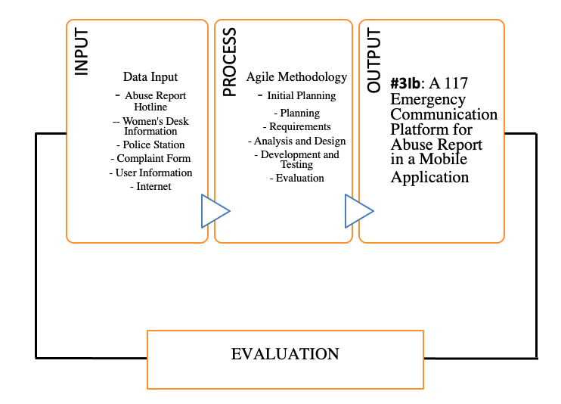

*Figure 1. Conceptual Framework*

As stated in the diagram above shown by the researchers, the following items listed in the input box are the source of data that is needed to process using the application. The software that will be used to develop the application are Java, Firebase (Realtime Database) and Android Studio. The hardware that will be used are android phone and laptop. The data that will be used to provide information to the application are gathered from the interview of police officers and reliable internet websites. In the process phase, the given information and tools in developing the prototype application will follow the agile methodology. With the help of the inputs and processes the mobile application will be developed. The researchers and end users will test the system to see if it works properly, and if bugs or errors are discovered, the developers will troubleshoot the issue, and once it has been resolved, the developers will test the system again to see if there are any remaining issues or if the system is working properly.

**Definition of Terms**

The following terms are defined either operationally or conceptually:

**Abuse -** the act of maltreatment towards a person or thing, with such cruelty on a repeated or regular basis, but in this study, it refers to the act of harming a certain person for the benefit of the other.

**Counselling -** defined as the process of having professional advice or help after experiencing a traumatic event.

**Data Analytics -** defined as the process of collecting and classifying the acquired data into an organized outcome or conclusion.

**Domestic Abuse -** is any incident or act of controlling, maltreatment, or threatening behavior towards intimate partners or family members regardless of gender or sexuality.

**Economic Abuse -** defined as the act that attempts to make a woman financially dependent to the spouse or partner, in accordance to the R.A. 9262 Anti-violence Against Women and Their Children Act of 2004.

**Emergency Communication Platform -** An application or website that serves as the new accommodating institution that provides much secured protocols and assistance.

**Firebase -** A realtime database that is being hosted by a cloud NoSQL database, that allows users to store and sync data and use access from any device (web or mobile).

**Psychological Abuse -** defined as the act of causing the victim to have a mental or emotional suffering, such as intimidation, harrasment, stalking, public humiliation, verbal abuse and mental infidelity, in accordance to the R.A. 9262 Anti-violence Against Women and Their Children Act of 2004.

**Pandemic -** affects multiple countries or continents. It has a larger impact and kills more people than an epidemic. In this study, the specific pandemic pertained to is the COVID-19 pandemic.

**Physical Abuse -** defined as the acts that includes bodily or physical harm, in accordance to the R.A. 9262 Anti-violence Against Women and Their Children Act of 2004.

**Sexual Abuse -** defined as the acts which is sexual in nature, that is commited againts the will of a woman or a child, such as rape, sexual harrasment, or treating a woman as sex object, in accordance to the R.A. 9262 Anti-violence Against Women and Their Children Act of 2004.

**METHODOLOGY**

Methodology is a set of procedures or techniques for locating, selecting, processing, and analyzing information about a subject. The methodology portion of a research article allows the reader to critically examine the study's overall validity and dependability (Leedy, 2021). This section will answer the questions such as how will the researchers gather the necessary data and analyze it. The researchers will discuss the research design, research instruments and the standards that will be used to analyze the data that will be collected.

**Research Design**

The researchers will use a quantitative descriptive type of approach because the purpose of the proposed study is to serve as a helpful way of reporting abuse cases through a mobile application and also to gather data regarding the abuse cases in the target locale. Quantitative research involves collecting numerical data and analyzing it mathematically to understand the phenomena. Quantitative research is further distinguished by the use of instruments such as questionnaires, interviews, and computers. Descriptive research is described as a research design that aims to accurately characterize existent occurrences (Atmowardoyo, 2018). Descriptive study designs are helpful for describing the desirable characteristics of the sample under investigation (Omair, 2015).

**Systems Development Methodology**

System development life cycle (SDLC) is a project management concept that describes the stages of an information system development project, from the first feasibility study to the ongoing maintenance of the finished product (Gillis, 2019). SDLC assists in the transformation of a concept into a fully functional and operating system. The researchers will use agile methodology for software development of the application. The agile model emphasizes the collaboration of the group, user feedback, continuous improvement, and the adapting capacity to changing activity. The stages of the methodology that the researchers used are initial planning, planning, requirements, analysis and design, development and testing, and evaluation.

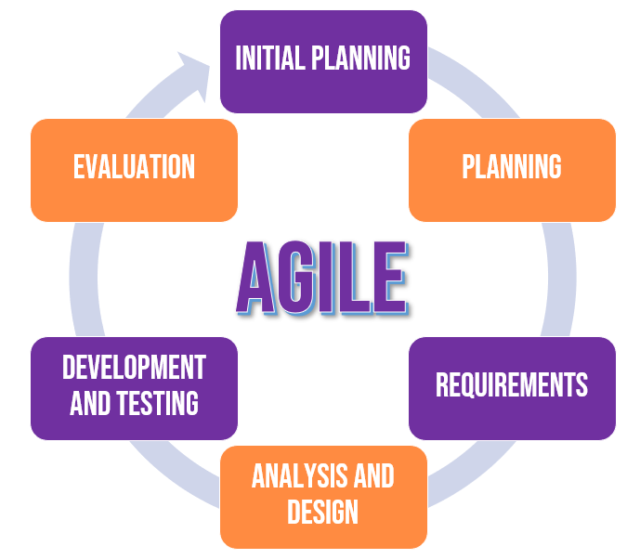

*Figure 2 Agile Systems Methodology*

**Initial Planning**

The researchers will collect data from different related literature, studies, and existing applications related to crime about abuse. A representative from PNP Women Desk was interviewed as part of the study. The researcher will be able to gain greater understanding of the demands of the application's users and some of the victims who have been reported with the support of official government input. Browsing the materials for the mobile application's development will also be done.

**Planning**

The researchers will evaluate the collected information in order to create all of the possible plans and objectives, as well as the application's concept and target clients.

**Requirements**

In order to complete all of the study's requirements. The researchers will begin organizing the data with the use of some hardware such as personal computers, mobile phones, and various software in order to construct and analyze the study.

**Analysis and Design**

Using different methods such as Data Flow Diagram (DFD) and Entity-Relationship Diagram (ERD), the researchers will design and conceptualize the layout and techniques of the mobile application in this phase. The flow of the #31b mobile application was analyzed using the DFD and ERD based on its function.

**Development and Testing**

The researchers will begin developing the application at this point, based on the ideas generated during the analysis and design, as well as the data acquired and the needs. The testing stage of the mobile application and admin website will verify if both are functioning properly and if it contains any possible errors or bugs. A variety of tests will be carried out to confirm that all relevant features are present.

**Evaluation**

Using the International Organization for Standardization (ISO) / International Electrotechnical Commission (IEC) 25010 and Likert Scale to determine the level of acceptance and usability of the #31b mobile application. Following the evaluation, the researchers will devise a strategy for improving and maintaining the mobile application in accordance with the findings.

**Research Instrument**

The research instrument will be in the form of a self-made survey questionnaire through Google Forms. The survey questionnaires contain questions, this questionnaire will help the researchers to determine and prove that the problem statement is correct. The method of doing research through surveys that researchers send to survey respondents is known as survey research. Survey data is then statistically examined in order to draw significant study results ("Survey research: Definition, examples and methods | QuestionPro," 2021). One of the most effective research methodologies has been demonstrated to be surveys. Survey assists in gathering essential information from a huge number of people, allowing you to reach a valid and objective judgment (Formplus Blog, 2020).

**Questionnaire**

The researchers used google forms as the form of the survey questionnaires. All questions were made to be answerable by Likert scale. There were three (3) types of questionnaires: for victim or witness, for police and for ordinary pampanga residents. The questionnaires were distributed to various respondents of the locale.

**Interview**

The researchers conducted a virtual interview with a former Women and Children Protection Desk Officer from Lubao, Pampanga. The objective of the interview was to know the current process of filing a complaint against an abuser, and the basic information needed for the complaint.

**Organizational Assessment of subjects**

The researchers will use random sampling design to determine the sample population within Pampanga. A sample drawn at random is supposed to be a fair reflection of the entire population ("What is random sampling? Definition of random sampling, random sampling meaning," 2021). According to the 2015 Census, Pampanga has a population of 2,198,110 people ("Pampanga," 2021). The researchers used the Raosoft website to determine the sample population which resulted in three hundred seventy-seven (377). Cluster sampling design is a probability sampling technique in which all elements of a population are classified into mutually exclusive and exhaustive groupings known as clusters (Frey, 2018). The Pampanga is divided into four (4) districts, the researchers will randomly select one (1) district and it will be the selected sample population for the study. 377 respondents will be equally divided into the six (6) municipalities that are under the selected district which is the 2nd Congressional District of Pampanga.

The municipalities covered in the 2nd Congressional District are; Floridablanca, Guagua, Lubao, Porac, Santa Rita, and Sasmuan. It has a total of 672,645 residents, taking up the 3.26% total population of Pampanga (Philippine Statistics Authority, 2015) with 159 barangays (Philippine Standard Geographic Code, 2021).

Per municipality there is a designated Police Station. Napolcom Regional Director Ronaldo Santos stated in an interview that the current ratio of the cop-population ratio in Central Luzon is 1:900 (Cervantes, 2019) therefore the rough estimated population of police officers in the 2nd District of Pampanga is seven hundred forty-seven (747). The researchers will use convenience sampling to determine the sample population of police officers. Due to the nature of their work and their availability, the researchers will only reach out to the available police respondents in the said municipalities.

The characteristics of the respondents are as follows; thirteen (13) years old and above, residing in the municipalities located in the 2nd District of Pampanga, victims of abuse, witnesses of abuse, male, female or LGBTQ+.

**Data Analysis**

The system will be evaluated using the software quality standard called International Organization for Standardization (ISO) / International Electrotechnical Commission (IEC) 25010 for the evaluation of the system. The researchers will follow the standard of ISO/IEC 25010 to categorize the mobile application functionalities. The ISO/IEC 25010 categorization of software quality requirements are follows: functional stability - to know what the mobile application does, performance efficiency - to know if the mobile application uses an optimal amount of resources, usability - to know if the specific user can use the mobile application in specific condition, reliability- to know if the mobile application is stable enough to cater the needs of the user, security - to know if the mobile application can protect information and data, (Britton, 2019)

The researchers will use Likert Scale to analyze the statistical data from the survey questionnaires and the evaluation tool. A Likert scale is a psychometric response scale that is commonly used in surveys to determine a participant's preferences or level of agreement with a statement or collection of statements and measures only one trait. Respondents are asked to use an ordinal scale to indicate their level of agreement with a specific proposition (Bertram, 2017). The researchers chose a four-point scale that will be used in the survey questionnaires and evaluation tool: 1 – Strongly disagree: 2 – Disagree: 3 –Agree: 4 –Strongly Agree.The gathered data will then be analyzed using the weighted mean and be interpreted.

WM = Σ*WV / N*

*Where*: WM = means weighted mean

WV= means weighted value

N = means number of cases

Σ = means summation

*Table 1.: Likert Four-Point Scale Interpretation*

| **POINT** | **SCALE RANGE** | **INTERPRETATION** |
| --- | --- | --- |
| 4 | 3.26 - 4.00 | Strongly Agree |
| 3 | 2.51 - 3.25 | Agree |
| 2 | 1.76 - 2.50 | Disagree |
| 1 | 1.00 - 1.75 | Strongly Disagree |

**Required Specification and Analysis**

The proposed system will benefit the users by providing a mobile application named #31b Emergency App, that would assist them to report the dangerous situation that they experienced. The said mobile application will enable them to describe their situation and report it to the local authorities using the application’s complaint form. The mobile application also displays information about emergency communication hotlines of police stations, social services and other health services offered by the municipal sector.

One of the business processes that the researchers and the users require is a management process which governs the system of operation of the user’s organization. These are case reporting and emergency response. Next, the supporting processes such as office personnel are put in place. The user’s requirement is to have an account that will be used in the mobile application and also a valid email and mobile number for the user’s verification.

The researchers analyzed similar studies found on the internet and noted more usable features that can be implemented in the proposed system. Therefore, the researchers came up with the idea that a handheld device is best suited for the reporting of abuse. The Android operating system found in these types of devices is more commonly used and most suitable to create customized applications that designs appropriate responses suited for different needs of the user.

Data flow diagrams were created by the researchers to illustrate a graphical representation of data flow via an information system and to define how the system would look and work. The entities involved in the data flow diagram are the user, super administrator, administrator, and the system. The super administrator and the administrator will be the ones who will manage and maintain the system, while the user is the one who will be using the system. The processes were also seen in the figures, as the user inputs data into the system, the system will then process the data and produce an organized information that will be sent into the database and will be monitored by the administrators.

The researchers used an Entity Relationship Diagram (ERD) to show the relationship between each table in the database. Entity Relationship Diagrams (ERDs) show how databases are organized logically. During the conceptual design stage of a system, diagrams become an indispensable tool. In the ERD, the tables and fields that will be used to manage the data inputs in the system. The tables include the tables for the users and cases. The fields of tables include the last name, first name, middle name, age, sex, contact, email, password and other important data needed to be processed. This data will also be used to show data analytics of the cases in the municipalities. These data representations will be able to help the authorities to strengthen their response services and to provide more protection to their locale.

The researchers also used flowcharts to show the processes and decisions that will be encountered in using the mobile application. A flowchart is a process that is represented graphically or symbolically. Each process step is represented by a separate symbol and includes a brief description of the stage (Hebb, 2021). The flowchart shows the starting process where the user will login or sign up into the application and then will land into the main page of the application. Then the user will see the different buttons that serve the choices of the services that will be catered by the application. The possible results of the choices are also shown in the flowchart and the processes until the end.

The researchers will analyze the gathered data from survey questionnaires given to the respondents to determine the need of the study and to prove the existing problem. With the help of the gathered data from the respondents, the researchers will formulate a plan of a system that will be able to solve the problem. After planning, the researchers will then proceed to designing the system and programming. The administrator website will be showing the current difference from gathered data through charts. The data that will be represented through charts are cases in the municipalities, age of victims, age of offenders etc.

In the database of the system, the database tables were normalized to prevent the redundancy of the data. Unique primary keys were used as Index identifier of the tables. Primary keys serve as the connecting keys of tables that form the relationship. The data in the tables consists of basic information of the complainant, the offender and the case.

The researchers will use the complaint form from the women’s help desk as the basis for the system. The complaint form is a paper that is needed to be filled up by the complainant and to be submitted to the help desk before the further investigation. Online filling of abuse reports in the proposed application primarily includes the abuser and the victim’s information as seen also in manual reporting. The color concept found in the user interface matches the Campaigns against Violence Against Women and Children (VAWC), the Philippine Commission on Women (PCW), and also the Domestic Abuse Awareness Campaigns which are the colors violet and orange. To create a suitable mobile application that can cater this project, the researchers will use the Android Studio to develop and simulate its overall graphical user interface to review the designs and arrange objects when the application runs on an actual android phone. The researchers will also use Firebase Database as the primary realtime database service to connect the application and administrator website to the database. The report data will be sent to the database where the #31b Emergency Officer and the Administrators can view and manage it.

*Table 2.: Development Hardware Specifications*

| **HARDWARE SPECIFICATIONS** | |
| --- | --- |
| **Item (Laptop)** | **Specifications** |
| Processor | Intel® Core™ i5-8300H 2.30GHz |
| Memory | 20480MB DDR4 SDRAM |
| Disk Space | 240GB SSD, 1TB HDD |
| Graphics | Nvidia GTX 1050 Ti 4GB |
|  | |
| **Item (Android Phone)** | **Specifications** |
| Processor | MediaTek Helio G85 Octa-core |
| Memory | 6GB RAM |
| Disk Space | 128GB ROM |
| Graphics | Mali-G52 MC2 |

*Table 3. Development Software Specifications*

| **SOFTWARE SPECIFICATIONS** | | |
| --- | --- | --- |
| **Item (Laptop)** | **Name** | **Version** |
| Operating System | Microsoft Windows | 10 |
| Integrated Development Environment (IDE) | Android Studio  Visual Studio Code | 4.2.1  1.62.1 |
| Open-source cross-platform web server | XAMPP | 8.0.12 |
| Database | Firebase Realtime Database | 2021 |
| Cloud Communication Platform | Sinch | 2021 |
|  | | |
| **Item (Android Phone)** | **Name** | **Version** |
| Operating System | Android 11 XOS | 7.6 |

The list of hardware components used by the researchers during the development of the system are shown in *Table 2 Development Hardware Specifications* and the following software programs of the described components are shown in *Table 3 Development Software Specifications* for the overall development and simulation of the application.

**Implementation Plan**

The proposed system is a prototype of a Mobile Application for Emergency Abuse Reporting. It means that the system requires the usage of an Android smartphone. During this phase, the researchers ensured that all of the goals stated during the planning and design phases were met, and that the system was thoroughly tested to ensure that all of the system's features and functional criteria were met. The existing system and the proposed system will be evaluated using the ISO/IEC 25010 as the systems evaluation tool. The results of each system will then be compared and analyzed. For the succeeding evaluation of the proposed system, the researchers will have the application tested by the respondents to test the application’s ability and reliability. Then, the researchers will be able to conduct training sessions for the ones who will manage the system and for primary users. The training sessions will serve as the way to explain how the system works and how to properly use it and execute the operations. By the end of the training sessions, the assigned administrators and primary users must be able to apply what they learned in the session and execute it accordingly. There will be a thorough monitoring of the proposed system's implementation for possible future usage in the local authority’s office.

**RESULTS AND DISCUSSION**

Results and Discussion is frequently regarded as the most important because it best demonstrates your ability as a researcher to think critically about an issue, develop creative solutions to problems based on the findings, and formulate a deeper, more profound understanding of the research (Davis, 2021). This section presents the gathered data results by the researchers from the google form survey questionnaires and evaluation form distributed to the respondents, wherein the respondents did evaluate the existing system and the proposed system. The respondents of the study were the Pampanga residents, Victim or Witness and Police Officers with a total number of 377 respondents. The evaluation form will determine the satisfaction of the respondents with the functional stability, reliability, usability, performance efficiency and security of the existing and proposed system.

**Survey Results**

The researchers managed to gather the complete number of respondents, 377 respondents from the 2nd District of Pampanga namely: Floridablanca, Guagua, Lubao, Porac, Santa Rita, and Sasmuan. The researchers sent google form links to the three types of respondents: victim or witness, police and Pampanga resident within the age bracket of thirteen (13) years old and above. The researchers tabulated the results and presented the final data in a pie chart and bar graph.

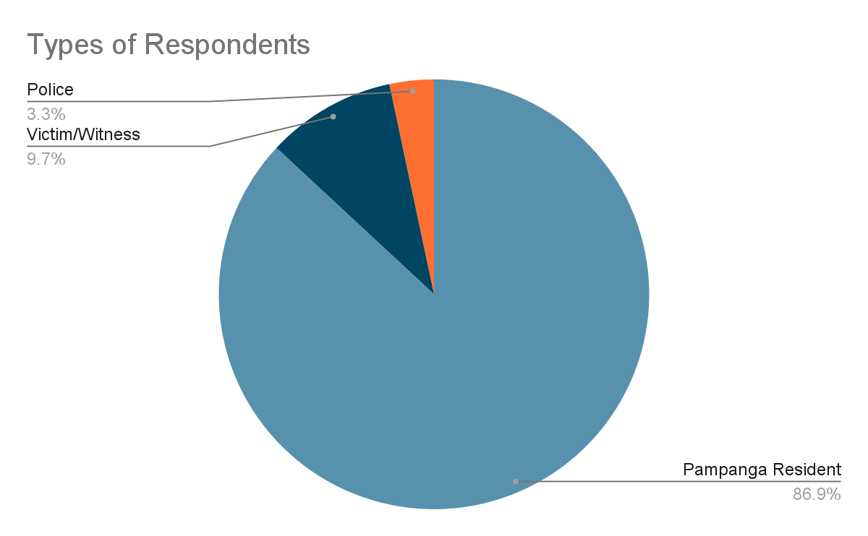

*Figure 3.  Types of Residents*

The pie graph shows that the highest percentage of respondents were from the pampanga residents with a total count of 339, followed by the victim or witness with 38 and the police with 13 respondents. Cluster sampling was used in determining the sample size of the pampanga residents and victims or witnesses; the 377 mark was reached. While for the police respondents, convenience sampling was conducted and the researchers were only able to reach out to 13 police respondents.

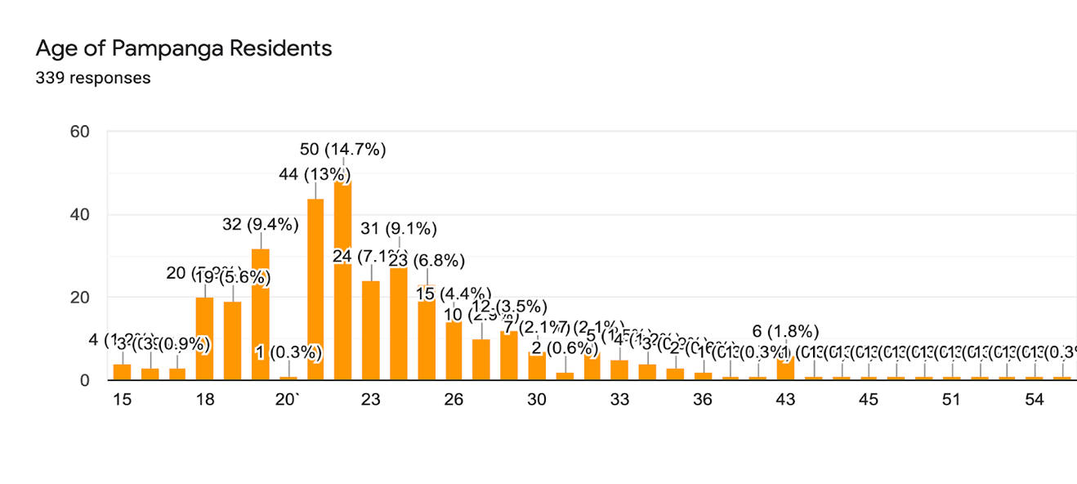

*Figure 4.  Age of Pampanga Residents*

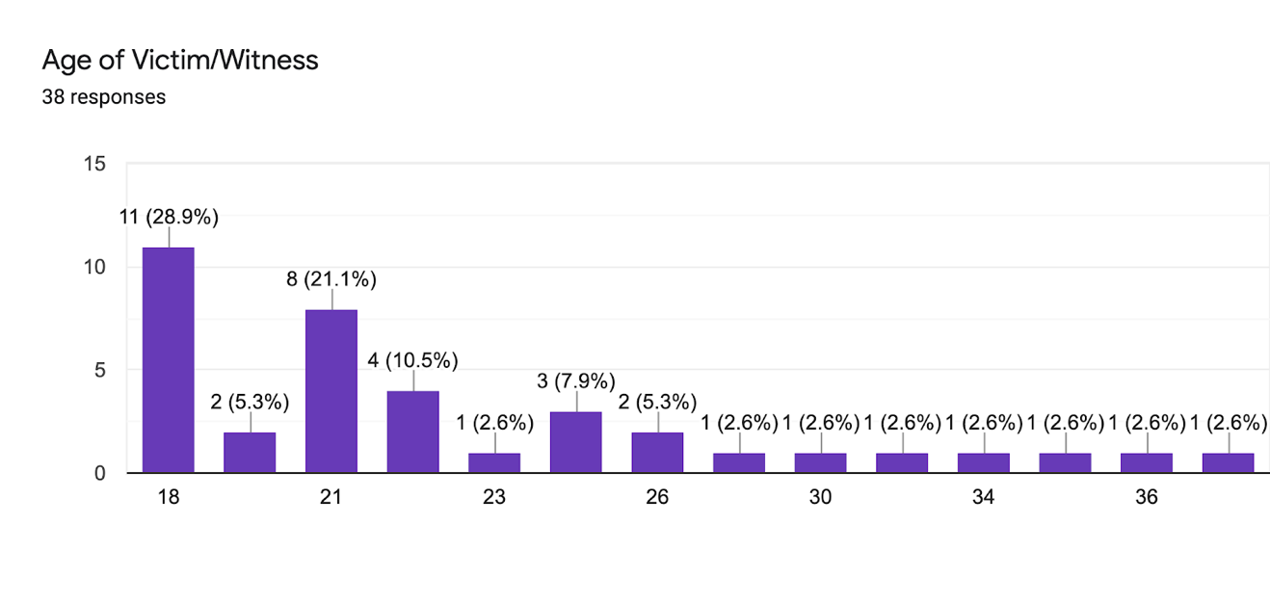

*Figure 5.  Age of Victim or Witness***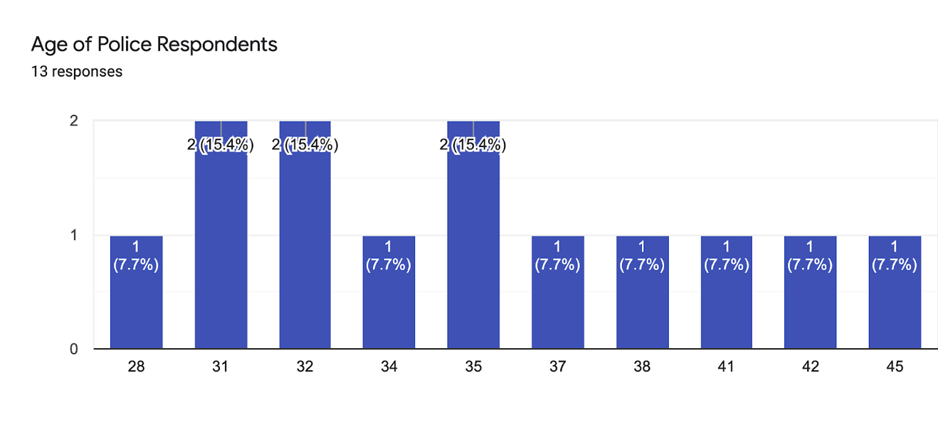**

*Figure 6  Police Respondents*

The corresponding bar graph shows the age distribution of the three types of respondents in the 2nd District of Pampanga. The age of Pampanga residents and victims fit in the age bracket stated by the researchers. The researchers gave clear instructions and explanations regarding the survey for the respondents to answer the survey properly.

**Pampanga Residents**

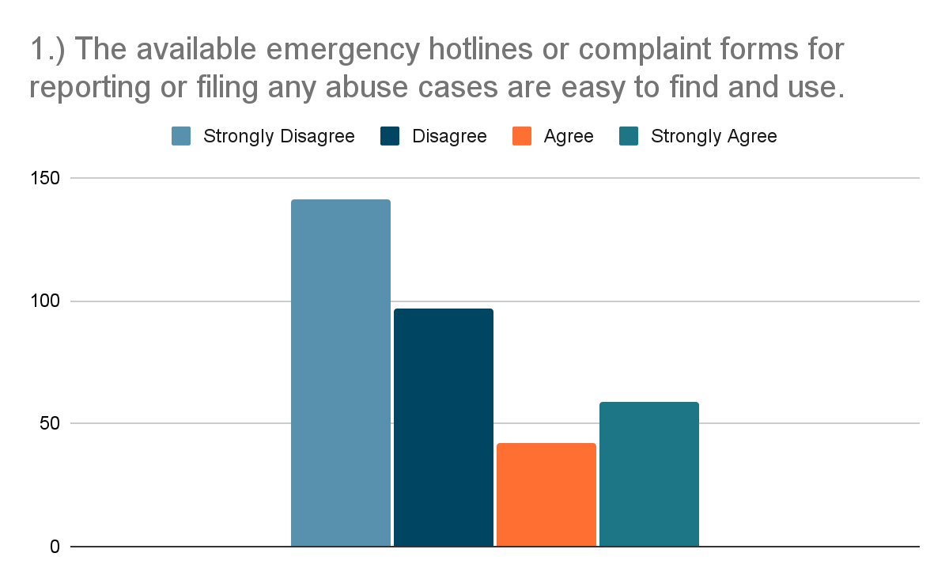

*Figure 7.  Pampanga Resident Survey question number 1 Results*

42% of the respondents strongly disagreed and 29% of the respondents disagreed with the statement that the available emergency hotlines for filing abuse cases are easy to find and use.

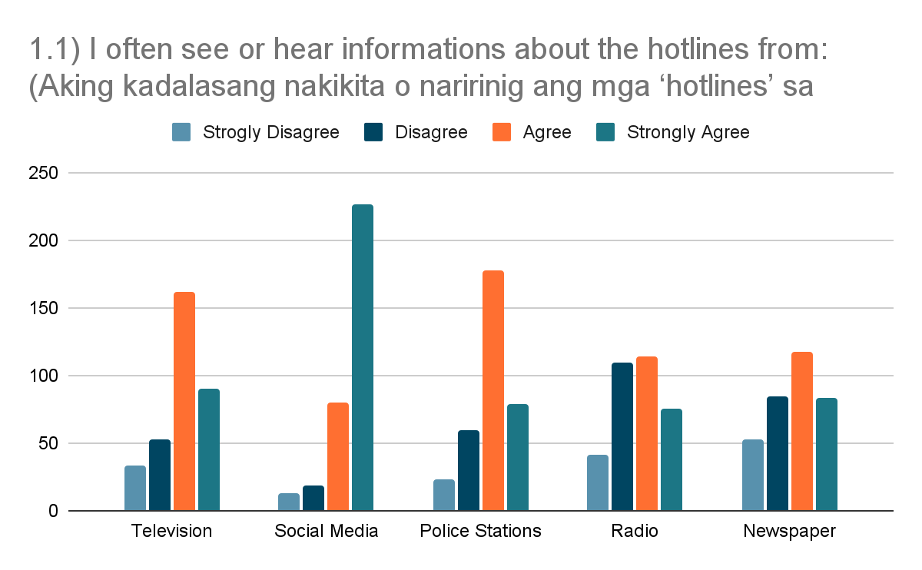

*Figure 8 Pampanga Resident Survey question number 1.1 Results*

67% of the respondents strongly agree that they often see or hear information about hotlines from social media platforms.

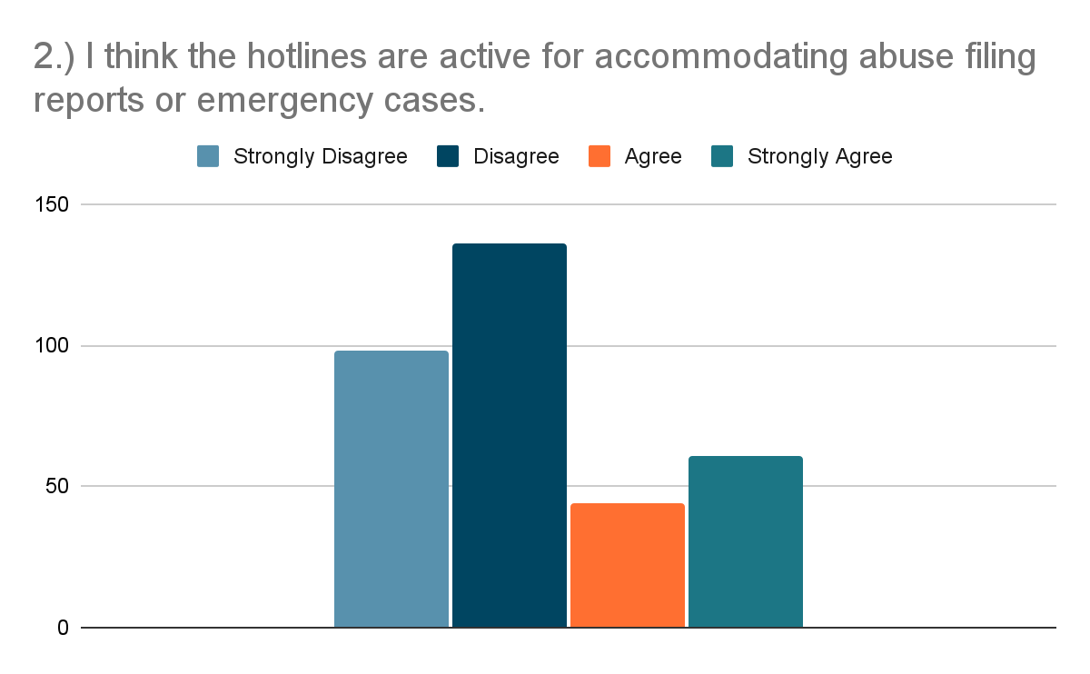

*Figure 9.  Pampanga Resident Survey question number 2 Results*

Pampanga residents showed disagreement with a percentage of 69% to the statement that says hotlines are active for accommodating abuse filing or emergency cases.

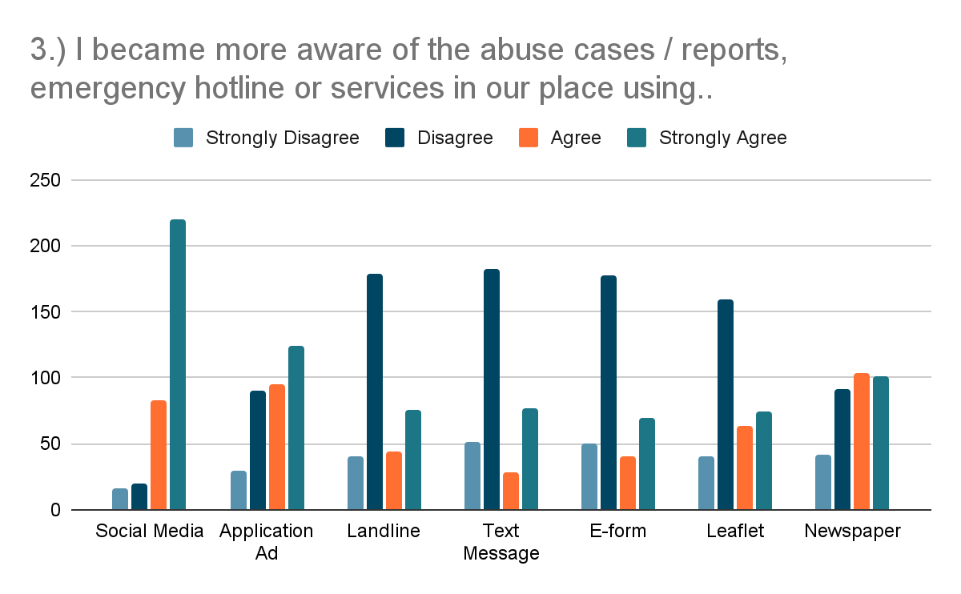

*Figure 10.  Pampanga Resident Survey question number 3 Results*

With a percentage of 65%, the respondents became more aware of the abuse cases or reports, hotlines, or services in their places using social media platforms.

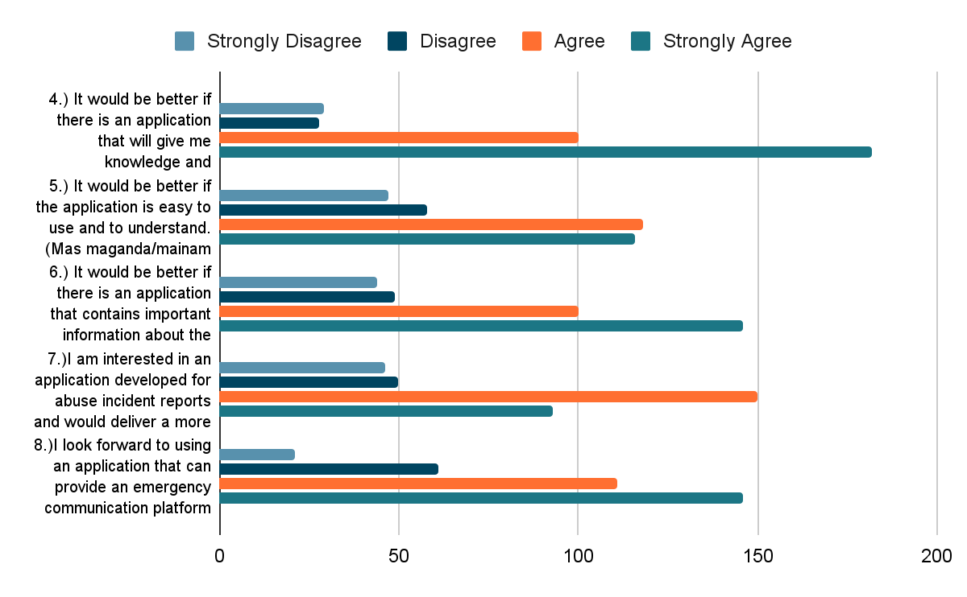

*Figure 11. Pampanga Resident Survey question number 4,5,6,7 and 8 Results*

The figure 11 shows the data from the series of questions pertaining to the interest of the respondents in the development of the study. The respondents strongly agreed and agreed to the statements that gave the researchers the reason to develop the study.

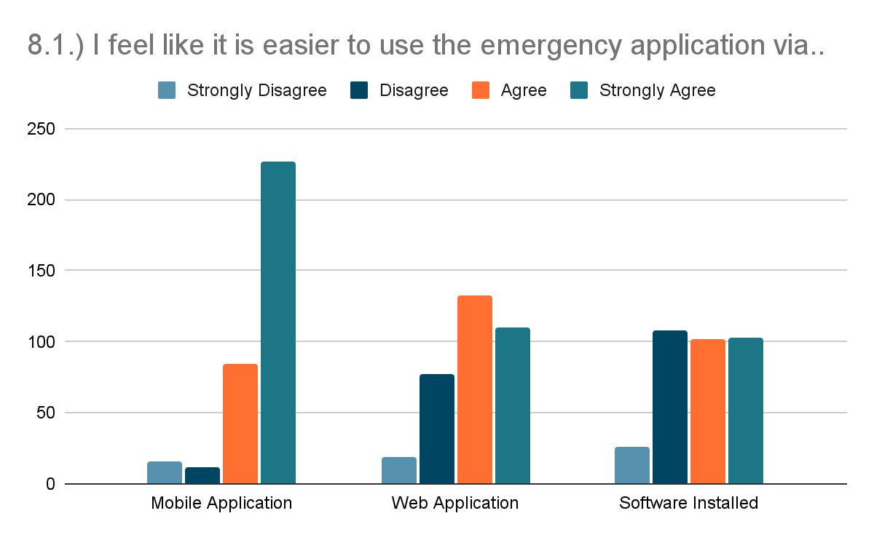

*Figure 12.  Pampanga Resident Survey question number 8.1 Results*

The bar graph shows the results of the survey questionnaire for the Pampanga residents. 82% of the respondents agreed to look forward to using an application that can provide an emergency communication platform.

**Victim/Witness**

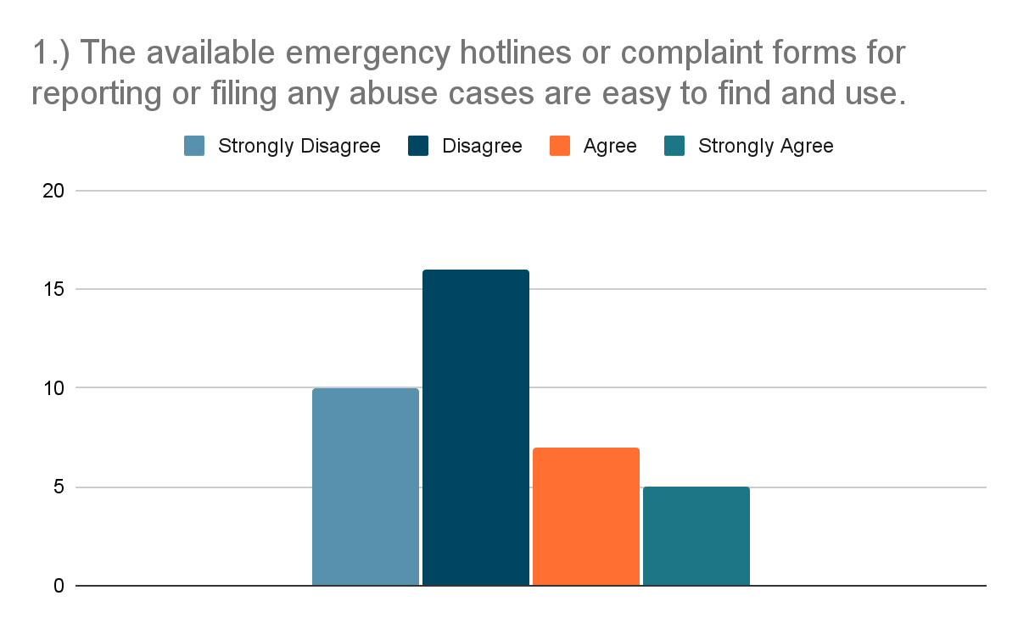

*Figure 13 Victim or Witness Survey question number 1 Results*

The colored bars represent the answers of the respondents. In the series of figures, the data projected that 68% of the respondents disagreed that the abuse emergency hotlines are easy to find.

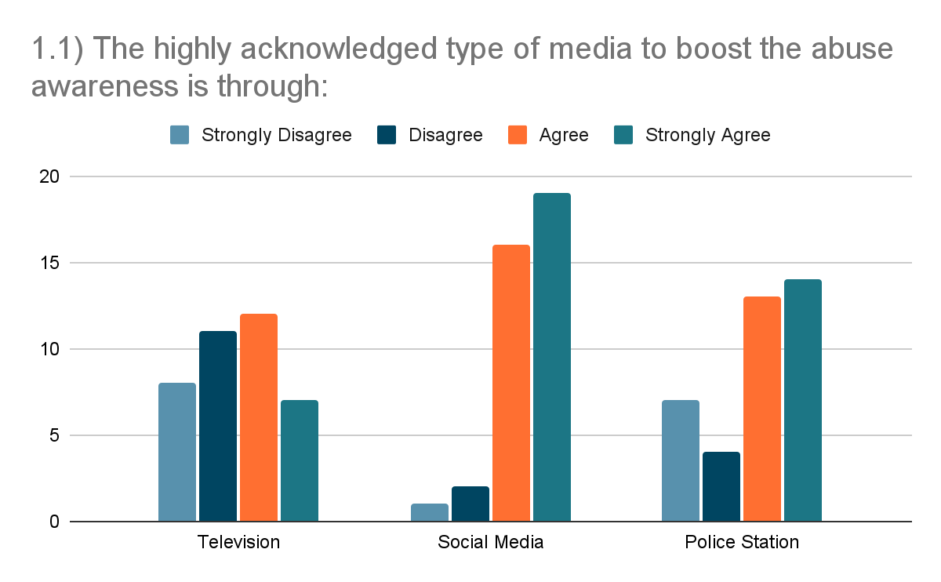

*Figure 14. Victim/Witness Survey question number 2 Results*

92% of the respondents agreed that the social media platform is the highest type of media used to boost abuse awareness.

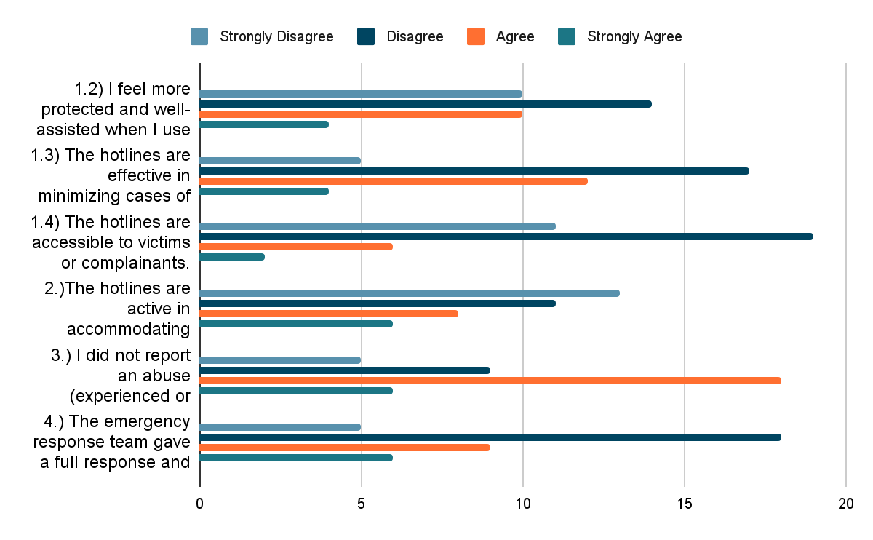

*Figure 15. Victim or Witness Survey question number 2,3,4 Results*

In the series of questions from question number 1.2 to question number 4, the respondents answered the questions based on their experiences. In question number 1.2, 37% of the respondents disagreed with the statement that they feel more protected and secured when they use the emergency hotline.  In question 1.3, 45% of the respondents disagreed with the statements that emergency hotlines are effective in minimizing abuse cases. In question 1.4, 50% of respondents disagreed with the statement that the hotlines are accessible to victims or complainants. In question number 2, 47% respondents agreed that they did not report abuse to emergency hotlines because they feel scared. Lastly, in question 4, 47% respondents disagreed with the statement that the emergency response team gave them a full response.

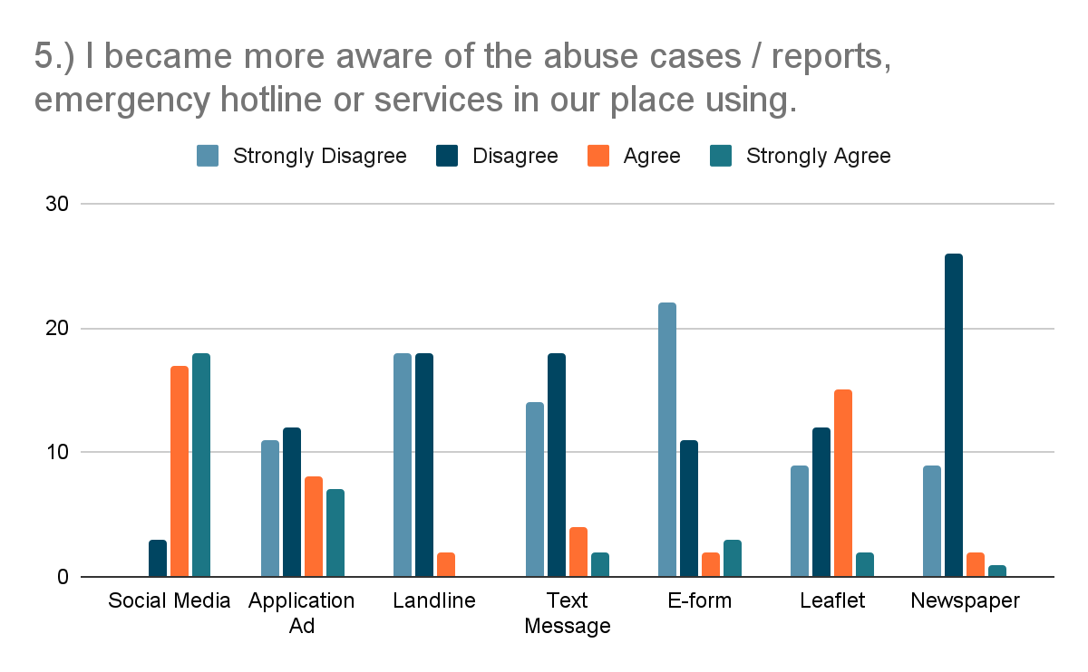

*Figure 16. Victim/Witness Survey question number 5 Results*

The social media platform received the highest responses with 45% agree responses and 47% strongly agree responses. That concludes that the respondents became more aware of abuse cases and reports, emergency hotlines or services through social media.

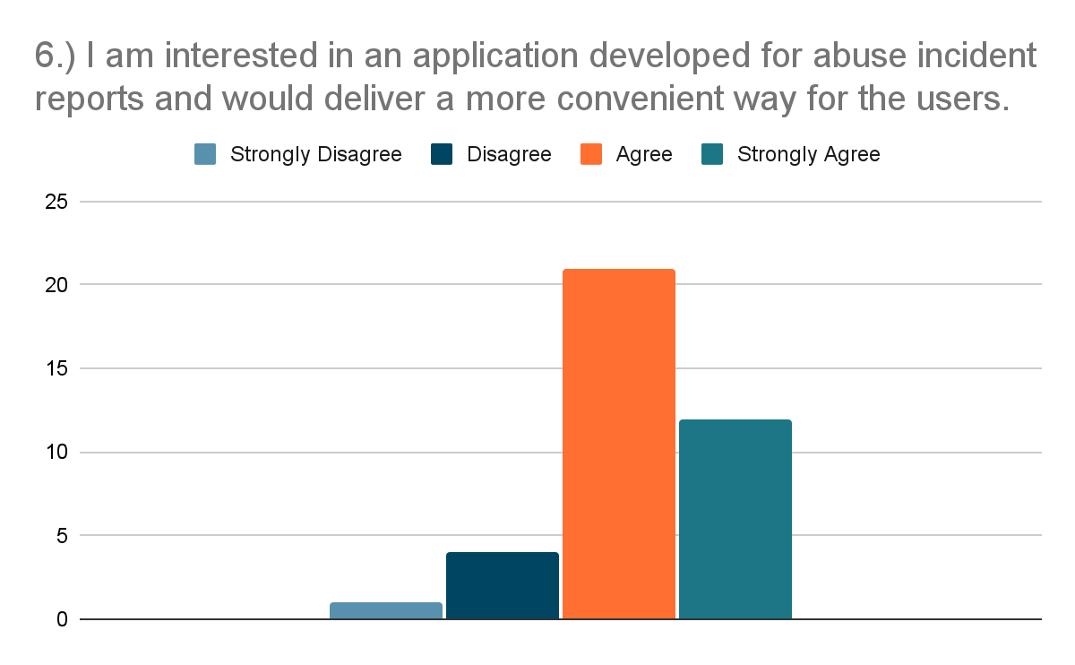

*Figure 17. Victim or Witness Survey question number 6 Results*

The bar graph shows the results of the survey questionnaire for the victim or witness. 87% of the respondents agreed that they are interested in using an application that can provide an emergency communication platform.

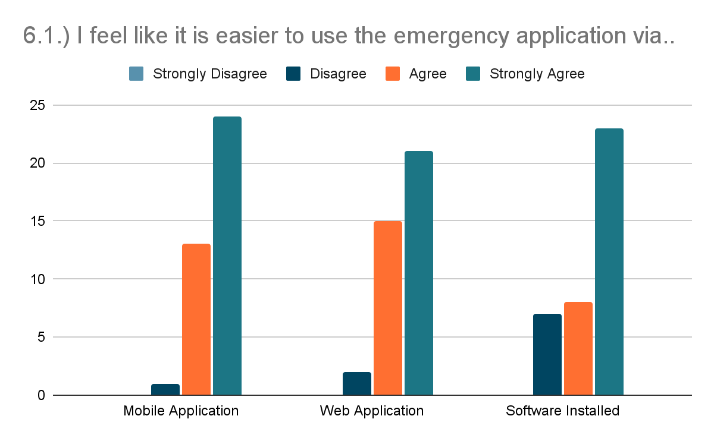

*Figure 18. Victim/Witness Survey question number 6.1 Results*

In the figure above, 63% of the respondents strongly agree that the emergency application is easier to use in a mobile application.

**Police Respondents**

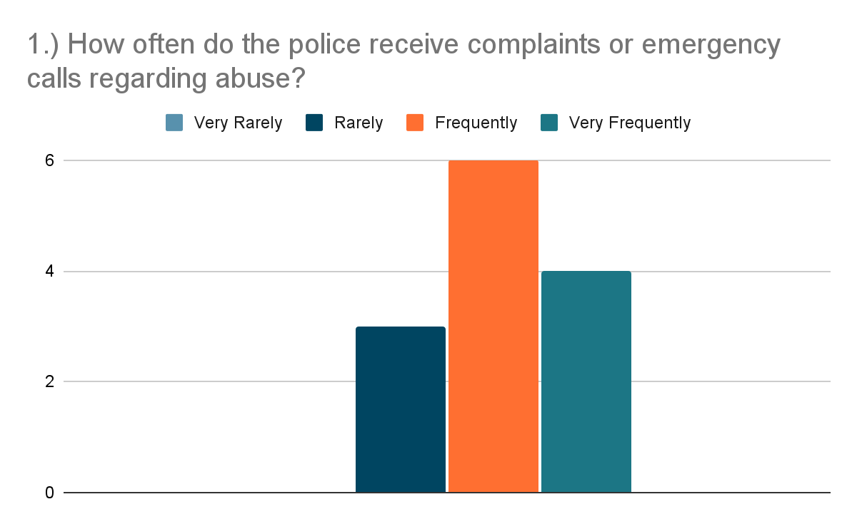

*Figure 19. Police Survey question number 1 Results*

In the figure above, the data shows that 77% of the respondents agreed that the police frequently receive complaints regarding abuse.

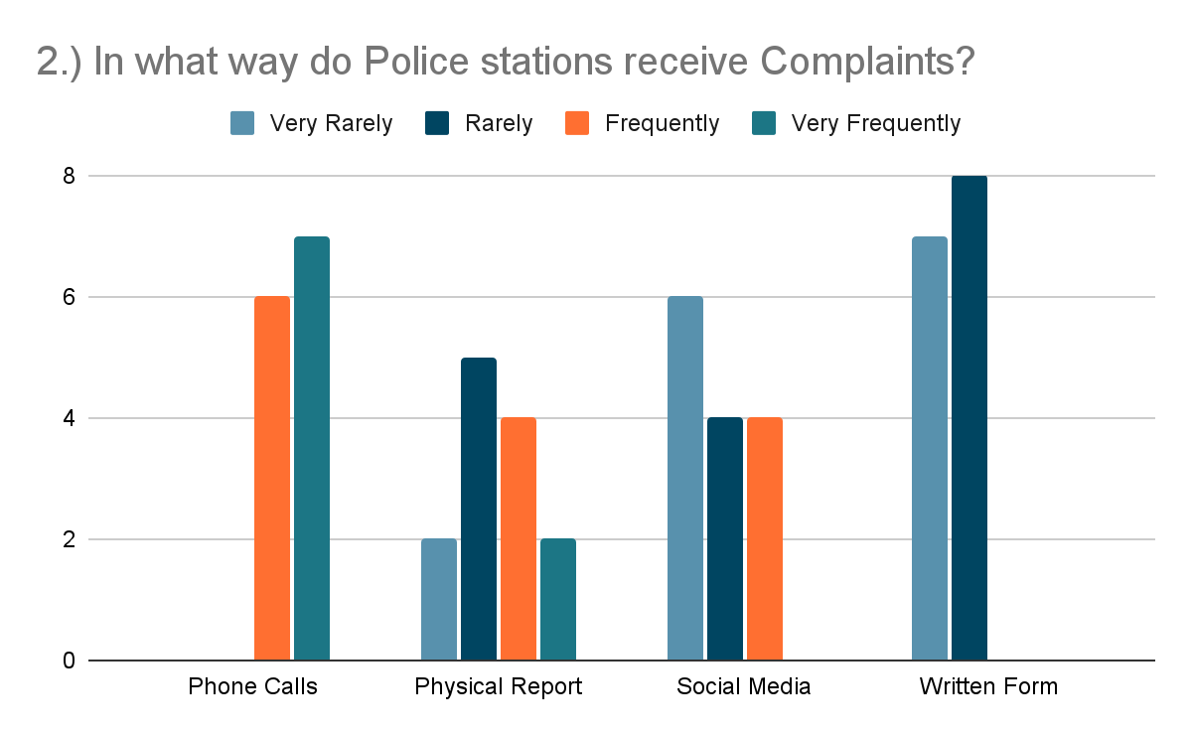

*Figure 20. Police Survey question number 2 Results*

In Figure 20 the data shows that Phone calls have 54% votes, the highest percentage of very frequent votes in terms of ways in receiving complaints.

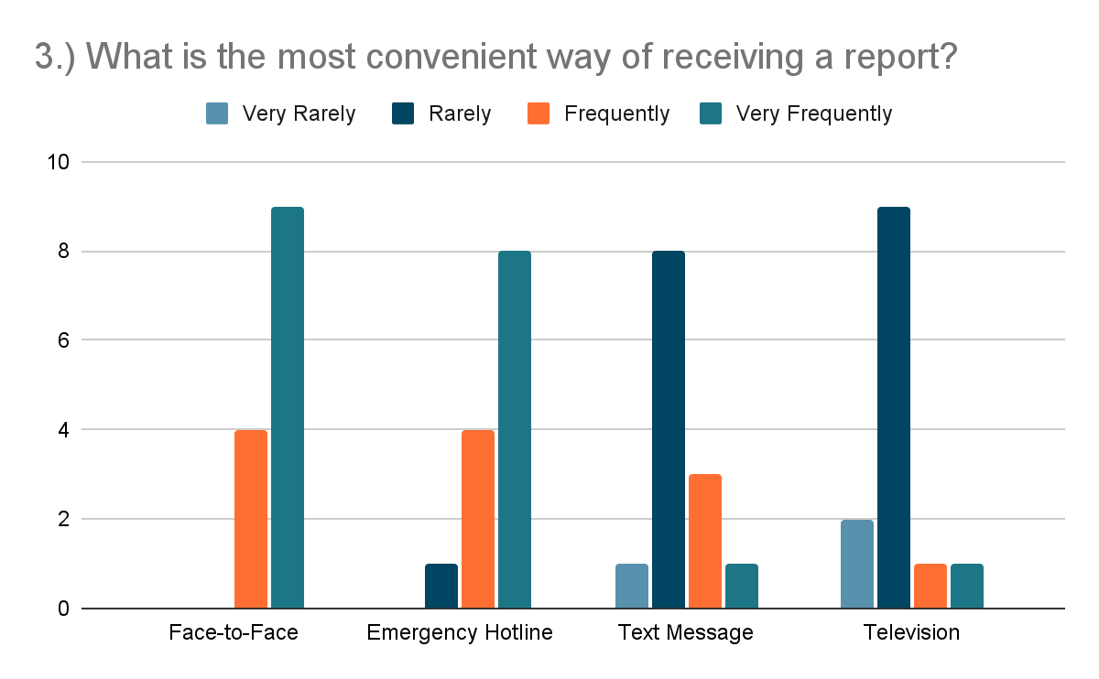

*Figure 21. Police Survey question number 3 Results*

The police officers chose Face-to-face as the most convenient method of receiving a report.

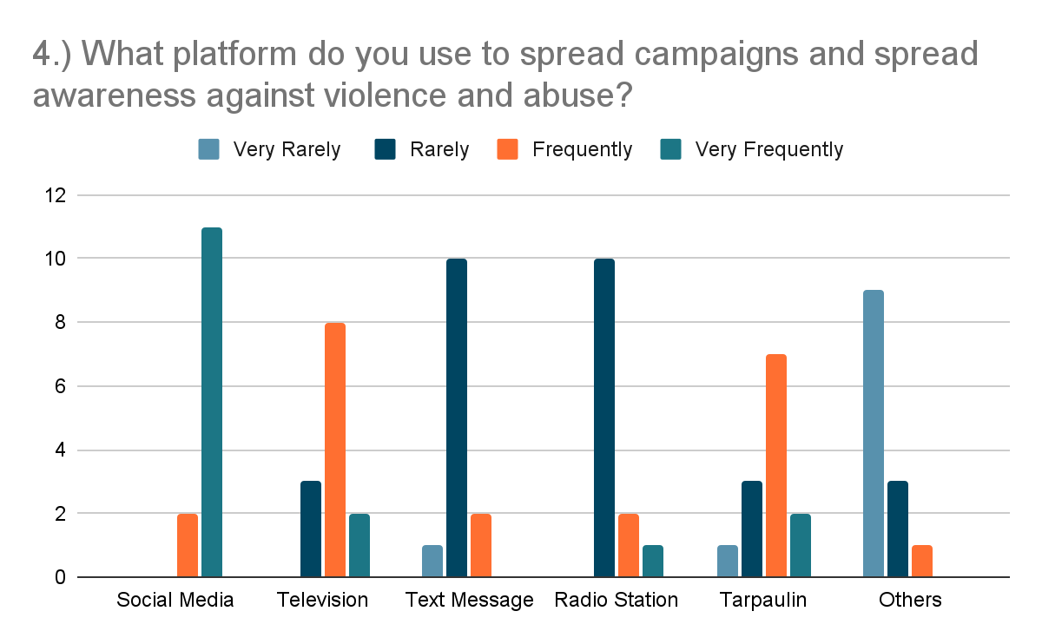

*Figure 22. Police Survey question number 4 Results*

Social Media platforms have the highest number of votes as the Very Frequently used platform to spread campaign and awareness.

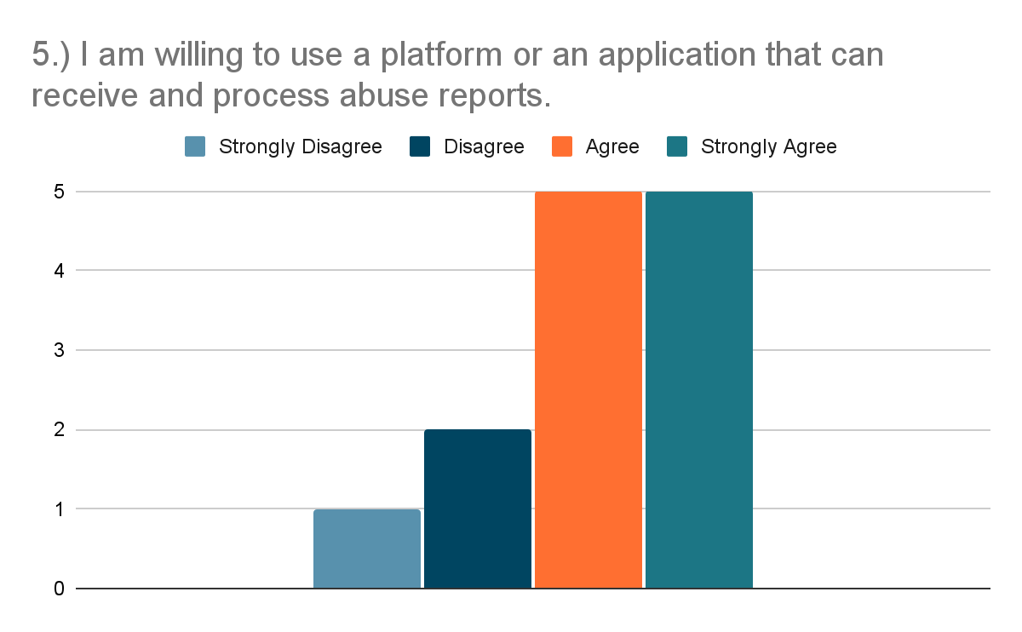

*Figure 23. Police Survey question number 5 Results*

The figure showed that 77% of the police respondents agreed that they are willing to use an application that can receive and collect abuse reports.

**Evaluation Results**

**Table 4. Evaluation of the Functional Stability of the Existing System.**

| **Indicators** | **4** | **3** | **2** | **1** | **WV** | **WM** | **I** |
| --- | --- | --- | --- | --- | --- | --- | --- |
| **Completeness**  The set of functions covers all the specified tasks and user objectives | **18**  (72) | **165**  (495) | **174**  (348) | **20**  (20) | **377**  **(935)** | **2.48** | **Disagree** |
| **Correctness**  The function provides the correct results with the needed degree of precision | **46**  (184) | **142**  (426) | **151**  (302) | **38**  (38) | **377**  **(950)** | **2.52** | **Agree** |
| **Appropriateness**  The function facilitate**s** the accomplishment of specified tasks and objectives | **38**  (152) | **173**  (519) | **124**  (248) | **42**  (42) | **377**  **(961)** | **2.55** | **Agree** |
| **Average Weighted Mean = 2.52 (Agree)** | | | | | | | |

As shown in table 4, the data representation indicated that the functional stability of the existing system is efficient enough to sustain a stable abuse case reporting platform. Stipulating an average mean computation of **2.52**, with the result interpretation level equivalent to **“Agree”** with reference to the functional stability of the said system. And having an average weighted mean as mentioned, this specifies that the existing system requires additional improvement with the actual service functionality, focusing on the overall completeness of the existing system.

**Table 5. Evaluation of the Reliability of the Existing System**

| **Indicators** | **4** | **3** | **2** | **1** | **WV** | **WM** | **I** |
| --- | --- | --- | --- | --- | --- | --- | --- |
| **Maturity**  The   system meets for reliability under normal operation | **32**  (128) | **134**  (402) | **126**  (252) | **85**  (85) | **377**  **(867)** | **2.30** | **Disagree** |
| **Availability**  The   system is operational and accessible when require for use | **49**  (196) | **144**  (432) | **147**  (294) | **37**  (37) | **377**  **(959)** | **2.54** | **Agree** |
| **Average Weighted Mean = 2.42 (Disagree)** | | | | | | | |

As shown in table 5, the data representation indicated that the reliability of the existing system is efficient enough to sustain a stable abuse case reporting platform. Stipulating an average mean computation of **2.42**, with the result interpretation level equivalent to **“Disagree”** with reference to the reliability of the said system. And having an average weighted mean as mentioned, this specifies that the existing system needed to improve the reliability function it performs, how the system must be highly operational and accessible at all times, requirements that the proposed system will resolve.

**Table 6.   Evaluation of the Usability of the Existing System**

| **Indicators** | **4** | **3** | **2** | **1** | **WV** | **WM** | **I** |
| --- | --- | --- | --- | --- | --- | --- | --- |
| **Appropriateness Recognizability**  User can recognize whether the   system is appropriate for their needs | **46**  (184) | **149**  (447) | **139**  (278) | **43**  (43) | **377**  **(952)** | **2.53** | **Agree** |
| **Operability**  The   system is easy to operate, control and appropriate to use | **42**  (168) | **465**  (495) | **125**  (250) | **77**  (77) | **377**  **(990)** | **2.63** | **Agree** |
| **User Interface Aesthetics**  A user interface enables pleasing and satisfying interactions for the user | **48**  (192) | **155**  (465) | **112**  (224) | **62**  (62) | **377**  **(943)** | **2.50** | **Disagree** |
| **Accessibility**  The   system can be used by people with the widest range of characteristics and capabilities to achieve a specified goal in a specified context of use. | **43**  (172) | **116**  (348) | **166**  (332) | **52**  (52) | **377**  **(904)** | **2.40** | **Disagree** |
| **Average Weighted Mean = 2.52 (Agree)** | | | | | | | |

As shown in table 6, the data representation indicated that the usability of the existing system is efficient enough to sustain a stable abuse case reporting platform. Stipulating an average mean computation of **2.52**, with the result interpretation level equivalent to **“Agree”** with reference to the usability of the said system. And having an average weighted mean as mentioned, this specifies that the existing system requires additional improvement with the usability function it performs. The researchers must provide a much capable, satisfying, and easy to use system, that the major usability goal is to serve the people or users at its finest, that the proposed system will resolve.

**Table 7. Evaluation of the Performance Efficiency of the Existing System**

| **Indicators** | **4** | **3** | **2** | **1** | **WV** | **WM** | **I** |
| --- | --- | --- | --- | --- | --- | --- | --- |
| **Time- behavior**  The response and processing times and throughout rates of the   system, when performing its functions meets the requirements | **39**  (156) | **166**  (498) | **109**  (218) | **63**  (63) | **377**  (935) | **2.48** | **Disagree** |
| **Average Weighted Mean = 2.48 (Disagree)** | | | | | | | |

As shown in table 7, the data representation indicated that the performance efficiency of the existing system is efficient enough to sustain an efficient abuse case reporting platform. Stipulating an average mean computation of **2.48**, with the result interpretation level equivalent to **“Disagree”** with reference to the performance efficiency of the said system. And having an average weighted mean as mentioned, this specifies that the existing system requires additional improvement with the performance efficiency functionality. Assessing the performance in time-behavior, on the quickness of response together with the efficiency of the processing, which will be resolved by the proposed system.

**Table 8.  Evaluation of the Security of the Existing System**

| **Indicators** | **4** | **3** | **2** | **1** | **WV** | **WM** | **I** |
| --- | --- | --- | --- | --- | --- | --- | --- |
| **Confidentiality**  The   system ensures that data are accessible only to those authorized to have access | **71**  (284) | **154**  (441) | **114**  (228) | **45**  (45) | **377**  **(998)** | **2.65** | **Agree** |
| **Integrity**  The   system prevents unauthorized access to, or modification of, computer programs or data | **74**  (296) | **161**  (483) | **79**  (158) | **63**  (63) | **377**  **(1000)** | **2.65** | **Agree** |
| **Average Weighted Mean = 2.65 (Agree)** | | | | | | | |

As shown in table 8, the data representation indicated that the security of the existing system is efficient enough to sustain a secured abuse cases reporting platform. Stipulating an average mean computation of **2.65**, with the result interpretation level equivalent to **“Agree”** with reference to the security of the said system. And having an average weighted mean as mentioned, this specifies that the existing system requires additional improvement with the security function it provides. The system needs to modify or upgrade its confidentiality and integrity, the authorization, roles, and its open accessibility to people or users, due to its open source demanding platform such as the written application for the complaint reports that can be a deficiency as an abuse complaining platform, which will be resolved by the proposed system.

**Table 9.  Evaluation of the Functional Stability of the Proposed System**

| **Indicators** | **4** | **3** | **2** | **1** | **WV** | **WM** | **I** |
| --- | --- | --- | --- | --- | --- | --- | --- |
| **Completeness**  The set of functions covers all the specified tasks and user objectives | **275**  (1100) | **102**  (306) | **0** | **0** | **377**  **(1406)** | **3.73** | **Strongly Agree** |
| **Correctness**  The function provides the correct results with the needed degree of precision | **262**  (1048) | **115**  (345) | **0** | **0** | **377**  **(1393)** | **3.69** | **Strongly Agree** |
| **Appropriateness**  The function facilitate**s** the accomplishment of specified tasks and objectives | **277**  (1108) | **98**  (294) | **0** | **0** | **377**  **(1402)** | **3.72** | **Strongly Agree** |
| **Average Weighted Mean = 3.71 (Strongly Agree)** | | | | | | | |

As shown in table 9, the data representation indicated that the functional stability of the proposed system is much more effective and stable for an abuse case reporting platform. Stipulating an average mean computation of **3.71**, with the result interpretation level equivalent to **“Strongly Agree”** with reference to the functional stability of the said system. And having an average weighted mean as aforementioned, specifies that the proposed system is effective in terms of functional stability.

**Table 10. Evaluation of the Reliability of the Proposed System**

| **Indicators** | **4** | **3** | **2** | **1** | **WV** | **WM** | **I** |
| --- | --- | --- | --- | --- | --- | --- | --- |
| **Maturity**  The system meets for reliability under normal operation | **252**  (1004) | **117**  (351) | **9**  (18) | **0** | **377**  **(1373)** | **3.64** | **Strongly Agree** |
| **Availability**  The   system is operational and accessible when require for use | **280**  (1120) | **93**  (279) | **4**  (8) | **0** | **377**  **(1407)** | **3.73** | **Strongly Agree** |
| **Average Weighted Mean = 3.69 (Strongly Agree)** | | | | | | | |

As shown in table 10, the data representation indicated that the reliability of the proposed system is much more effective and reliable for an abuse case reporting platform. Stipulating an average mean computation of **3.69**, with the result interpretation level equivalent to **“Strongly Agree”** with reference to the functional stability of the said system. And having an average weighted mean as aforementioned, specifies that the proposed system fulfilled the additional improvement needed of the existing system, indicating that the system is highly operational, accessible and available at all times.

**Table 11.  Evaluation of the Usability of the Proposed System**

| **Indicators** | **4** | **3** | **2** | **1** | **WV** | **WM** | **I** |
| --- | --- | --- | --- | --- | --- | --- | --- |
| **Appropriateness Recognizability**  User can recognize whether the   system is appropriate for their needs | **284**  (1132) | **90**  (270) | **4**  (8) | **0** | **377**  **(1407)** | **3.73** | **Strongly Agree** |
| **Operability**  The   system is easy to operate, control and appropriate to use | **298**  (1192) | **79**  (237) | **0** | **0** | **377**  **(1429)** | **3.79** | **Strongly Agree** |
| **User Interface Aesthetics**  A user interface enables pleasing and satisfying interactions for the user | **314**  (1256) | **62**  (186) | **0** | **0** | **377**  **(1442)** | **3.82** | **Strongly Agree** |
| **Accessibility**  The   system can be used by people with the widest range of characteristics and capabilities to achieve a specified goal in a specified context of use. | **280**  (1120) | **92**  (276) | **5**  (10) | **0** | **377**  **(1406)** | **3.73** | **Strongly Agree** |
| **Average Weighted Mean = 3.77 (Strongly Agree)** | | | | | | | |

As shown in table 11, the data representation indicated that the usability of the proposed system is much more effective and usable, it can sustain a stable abuse case reporting platform. Stipulating an average mean computation of **3.77**, with the result interpretation level equivalent to **“Strongly Agree”** with reference to the usability of the said system. And having an average weighted mean as mentioned, this specifies that the proposed system fulfilled the required additional improvement with the usability function it performs. Additional improvements such as information boards and submitting of complaint forms in one application allows the user to easily use the application. Also, a more interesting interface to make the users more engaged in the application and its content.

**Table 12. Evaluation of the Performance Efficiency of the Proposed System**

| **Indicators** | **4** | **3** | **2** | **1** | **WV** | **WM** | **I** |
| --- | --- | --- | --- | --- | --- | --- | --- |
| **Time- behavior**  The response and processing times and throughout rates of the   system, when performing its functions meets the requirements | **273**  (1092) | **97**  (291) | **7**  (14) | **0** | **377**  **(1397)** | **3.70** | **Strongly Agree** |
| **Average Weighted Mean = 3.70 (Strongly Agree)** | | | | | | | |

As shown in table 12, the data representation indicated that the performance efficiency of the proposed system is much more effective for an abuse case reporting platform. Stipulating an average mean computation of **3.70**, with the result interpretation level equivalent to **“Strongly Agree”** with reference to the performance efficiency of the said system. And having an average weighted mean as mentioned, this specifies that the proposed system fulfilled the required additional improvement with the performance efficiency function it performs. Indicating assessed time-behavior, with quick response together with the high efficiency data processing.

**Table 13.  Evaluation of the Security of the Proposed System**

| **Indicators** | **4** | **3** | **2** | **1** | **WV** | **WM** | **I** |
| --- | --- | --- | --- | --- | --- | --- | --- |
| **Confidentiality**  The   system ensures that data are accessible only to those authorized to have access | **308**  **(1228)** | **64**  **(192)** | **6**  **(12)** | **0** | **377 (1432)** | **3.79** | **Strongly Agree** |
| **Integrity**  The   system prevents unauthorized access to, or modification of, computer programs or data | **286(1144)** | **87**  **(261)** | **4**  **(8)** | **0** | **377**  **(1413)** | **3.74** | **Strongly Agree** |
| **Average Weighted Mean = 3.77 (Strongly Agree)** | | | | | | | |

As shown in table 13, the data representation indicated that the performance efficiency of the proposed system is much more effective and secured for an abuse cases reporting platform Stipulating an average mean computation of **3.77**, with the result interpretation level equivalent to **“Strongly Agree”** with reference to the security of the said system. And having an average weighted mean as mentioned, this specifies that the proposed system fulfilled the required additional improvement with the security function. The system modified and upgraded the confidentiality and integrity, the authorization, roles, and the secured accessibility of the users.

**Table 14.  Proposed System Testing Result Summary**

|  | **Existing System** | | **Proposed System** | |
| --- | --- | --- | --- | --- |
| **Indicators** | **Mean** | **Interpretation** | **Mean** | **Interpretation** |
| Functional Stability | 2.52 | Agree | 3.71 | Strongly Agree |
| Reliability | 2.42 | Disagree | 3.69 | Strongly Agree |
| Usability | 2.52 | Agree | 3.77 | Strongly Agree |
| Performance Efficiency | 2.48 | Disagree | 3.70 | Strongly Agree |
| Security | 2.65 | Agree | 3.77 | Strongly Agree |
| **AVERAGE MEAN** | **2.52** | **Agree** | **3.73** | **Strongly Agree** |

For the summary result shown in table 14, the representation indicates that the proposed system impact has an average mean of 3.73, which corresponds to an interpretation level equivalent to “Strongly Agree”, specifying that the proposed system’s average mean (3.73) compared to the existing system’s average mean (2.52), with an interpretation level of “Agree”, which is shown in table 9. With a difference of (1.21) in the average means where in the proposed system resulted higher, this signifies that the proposed system has a greater impact and advantage to the users than the existing system in terms of functional stability, reliability, usability, performance efficiency and security.

As stated in the objectives of the study, the purpose of the application is to help the user to easily report a difficult situation in an easily accessible way. The application can also help the users gain awareness regarding abuse cases and basic knowledge in determining if an abuse case is present in their area. The proposed study  also gives enough information about the institutions and stations that could help or assist a victim.

Surveys were conducted to test the functional stability, reliability, usability, performance efficiency and security of the study. The result of the survey showed that the majority of the respondents strongly agreed to the proposed system compared to the existing system.

The application offers a complaint report function through the use of the internet. Even though an alternative way through the use of Facebook Messenger was deployed by the national authority, the application still has a more enhanced functionality. Through the use of the application, the database of the complaint reports will be organized as the application only focuses on submitting reports and also giving reliable information for better awareness of the people. One of the objectives of the study is to provide accurate information about the local authorities such as telephone numbers and locations. Also, providing the information about the nearby facilities that could help for the betterment of a person’s well-being. An information board that also tackles on how to identify if a person is being abused and what are the ways to report the abuse and stop it. The visual aesthetics of the application also helped in giving interest to the users. All of these are utilized in one application that will give benefit to the users.

The application #31b: A 117 Emergency Communication Platform for Abuse Report in a Mobile Application will be useful and efficient in the midst of the pandemic and even after the pandemic ends. There are still a lot of cases where the offender hinders their victim from going out of their sight. With the use of the proposed system, the user will be able to seek help with the use of the internet. The existing system’s function is still serviceable but based on the survey conducted shows that the existing system still has room for improvement.

**SUMMARY**

With the problems discovered by the researchers, the idea of the mobile application that would offer an additional easy way of communication came up. The mobile application is considered as an alternative way of reporting to the authorities to help victims and witnesses end an abuse. Overall, the mobile application is not only a communication platform for the victims but also an informative platform that can raise awareness about abuse cases to everybody. The mobile application also has an administrator website, where the in-charge desk officer will be able to see the complaints that are coming in from the mobile application. Complaints submitted by the mobile application are stored in the Firebase Realtime database and organized in the administrator website.

**CONCLUSION**

The overall study was concluded successful as the aim and objective of the #31b: A 117 Emergency Communication Platform for Abuse Report in a Mobile Application was met successfully. The application was able to provide an additional way of submitting a complaint report to the authorities. Also, by providing helpful information such as emergency hotlines, stations, institutions and facilities for the victims. Through the months of development using the agile methodology, the system showed strengths and underwent many improvements of its features and functionalities. In the evaluation survey, The respondents found out that they Strongly Agree in terms of security with an average mean of 3.77%, usability with an average mean of 3.77% and functional stability with an average mean of 3.71%. Therefore, the researchers concluded that the results are in line with the overall quality of the proposed system.

**RECOMMENDATION**

The researchers still await the opportunity to add more features and functionalities in the proposed system. Therefore, the researchers recommend the following improvements and additional upgrade features for the next researchers that would like to take the similar study. Firstly, the adjusting and enhancement of the administrator’s website and mobile application appearance, adding more functionality for data visualization, additional language support for local users, and a new user sign-up authentication feature using the National Identification number issued by the Philippine Statistics Authority (PSA).

Furthermore, for more prospective implementations and approaches of this study, the System Development Life Cycle is the one to take in mind of the next researchers. The SDLC is widely used in many companies and organizations by those who develop android applications and websites. The use of multi-platform application development can address the accessibility and usability to different mobile operating systems, to accommodate and help more users.

# References

(2021). Retrieved from Philippine Statistics Authority. : https://psa.gov.ph/classification/psgc/?q=psgc%2Fcitimuni%2F035400000

Abdullah, J. e. (2020). An Application of the Theory of Planned Behavior in Predicting Child Abuse Reporting Intention of Malaysian Society. *KnE Social Sciences,*, 225-238.

Abellán, E. (2020, February 6). *What’s the Agile methodology and how can it benefit your enterprise?* . Retrieved from Digital Marketing Agency and Consultancy Online | WAM. : https://www.wearemarketing.com/blog/what-is-the-agile-methodology-and-what-benefits-does-it-have-for-your-company.html

Atmowardoyo, H. (2018). Research Methods in TEFL Studies: Descriptive Research, Case Study, Error Analysis, and R & D. *Journal of Language Teaching and Research, Vol. 9, No. 1*, 197-204.

Balahadia, F., & Mortel, Z. (2020). iJuanaHelpMo: Web and Mobile Application for Reporting Violence: A Framework for Developing Violence Against Women Application. *Asia Pacific Journal of Multidisciplinary Research, Volume 8, No. 3*, 30-36.

Bertram, D. (2017, May). *Likert Scales.* Retrieved from Welcome to Digilib UIN Sunan Ampel Surabaya - Digilib UIN Sunan Ampel Surabaya. : https://digilib.uinsby.ac.id/750/6/Bab%203.pdf

Blog, F. (2020, November 3). *Survey research: Types, examples & methods*. Retrieved from Create Free Online Forms & Surveys in 2 Mins | Formplus.: https://www.formpl.us/blog/survey-research

Britton, J. (2021, May 6). *What is ISO 25010?* Retrieved from Perforce Software. : https://www.perforce.com/blog/qac/what-is-iso-25010

Calleja, J. (2020, October 9). *Domestic violence all the rage in Philippine lockdown*. Retrieved from ucanews.com: https://www.ucanews.com/news/domestic-violence-all-the-rage-in-philippine-lockdown/89821

Campbell, J. (2020, July 6). *Coronavirus and Domestic Violence: What You Should Know.* Retrieved from Johns Hopkins Medicine. : https://www.hopkinsmedicine.org/health/conditions-and-diseases/coronavirus/coronavirus-and-domestic-violence-what-you-should-know

Ceccato, V. (2019). Eyes and Apps on the Streets: From Surveillance to Sousveillance Using Smartphones. *Criminal Justice Review*, 44(1), 25-41.

Cervantes, D. (2019, February 7). *NAPOLCOM LAMENT 1:900 cop-population ratio in Central Luzon*. Retrieved from Punto!Central Luzon: https://punto.com.ph/napolcom-lament-1900-cop-population-ratio-in-central-luzon/

Frey, B. (2018). *Cluster sampling - SAGE research methods. SAGE Research Methods:* . Retrieved from Find resources to answer your research methods and statistics questions. : https://methods.sagepub.com/reference/the-sage-encyclopedia-of-educational-research-measurement-and-evaluation/i4962.xml

Gillis, A. (2019, June 21). *What is a systems development life cycle?* Retrieved from Definition from WhatIs.com. SearchSoftwareQuality. : https://searchsoftwarequality.techtarget.com/definition/systems-development-life-cycle

Gonzalez, G. (2020, December 14). *Violence against women and girls: A pandemic we must end now*. Retrieved from Philippines. ReliefWeb. : https://reliefweb.int/report/philippines/violence-against-women-and-girls-pandemic-we-must-end-now

Harpe, S. (2015). *How to analyze Likert and other rating scale data.* Retrieved from ScienceDirect.com | Science, health and medical journals, full text articles and books. : https://www.sciencedirect.com/science/article/pii/S1877129715200196?via%3Dihub

Hebb, N. (2021). *What is a flow chart?* Retrieved from Flowchart Software and Excel Utility Add-ins | BreezeTree.: https://www.breezetree.com/articles/what-is-a-flow-chart

Ibrahim, E. e. (2021). Tina: Empowerment Based Design for Domestic Violence Survivors Mobile Application. . *Turkish Journal of Computer and Mathematics Education (TURCOMAT), 12(3)*, 2129-2135.

Kluger, J. (2021, February 3). *Domestic Violence Is a Pandemic Within the COVID-19 Pandemic*. Retrieved from Time: https://time.com/5928539/domestic-violence-covid-19/

Kuehn, B. M. (2020, August 18). *Surge in Child Abuse, Harm During COVID-19 Pandemic Reported*. Retrieved from JAMA Network | Home of JAMA and the Specialty Journals of the American Medical Association: https://jamanetwork.com/journals/jama/fullarticle/2769482

Leedy, P. (2021, May 26). *LibGuides: Research support: Research methodology.* Retrieved from LibGuides at University of the Witwatersrand. : https://libguides.wits.ac.za/c.php?g=693518&p=4914913

Makati-Medical-Center. (2020, Ocotber 28). *Domestic Violence and the Pandemic: What You Should Know.* Retrieved from Makatimed.net: https://www.makatimed.net.ph/news-and-exhibits/news/domestic-violence-and-the-pandemic-what-you-should-know

Neelam, V. (2018). *Mobile Application for Survivors of Domestic Violence.* Retrieved from Georgia State University: https://scholarworks.gsu.edu/iph_capstone/94/

Norowi, N., Hairudin, S., & Abdullah, L. (2021). RELAYVIO: Mobile Application for Documenting Domestic Violence. *Asia-Pacific Journal of Information Technology and Multimedia*, 63-73.

Omair, A. (2015). Selecting the appropriate study design for your research: Descriptive study designs. *Journal of Health Specialties / July 2015 / Vol 3 | Issue 3*, 153-156. Retrieved from ResearchGate | Find and share research. : https://www.researchgate.net/profile/Aamir-Omair-2/publication/281223251_Selecting_the_appropriate_study_design_for_your_research_Descriptive_study_designs/links/583d323608ae3cb63656dfff/Selecting-the-appropriate-study-design-for-your-research-Descriptive

Ortuoste, J. (2021, March 12). *Violence against women, a major concern during pandemic.* Retrieved from Manila Standard.: https://manilastandard.net/mobile/article/349238

*Pampanga*. (2015). Retrieved from PhilAtlas.: https://www.philatlas.com/luzon/r03/pampanga.html

Pereda, N., & Díaz-Faes, D. A. (2020). *Family violence against children in the wake of COVID-19 pandemic: A review of current perspectives and risk factors.* Retrieved from Child Adolesc Psychiatry Ment Health : https://doi.org/10.1186/s13034-020-00347-1

Ranada, P. (2020, May 9). *During coronavirus lockdown: Abused women, children more vulnerable*. Retrieved from Rappler: https://www.rappler.com/newsbreak/in-depth/during-coronavirus-lockdown-abused-women-children-more-vulnerable

Rashkovits, R., & Lavy, I. (2021, February). *MAPPING COMMON ERRORS IN ENTITY RELATIONSHIP DIAGRAM DESIGN OF NOVICE DESIGNERS.* Retrieved from International Journal of Database Management Systems (IJDMS).: https://d1wqtxts1xzle7.cloudfront.net/66039693/13121ijdms01.pdf?1615963444=&response-content disposition=inline%3B+filename%3DMAPPING_COMMON_ERRORS_IN_ENTITY_RELATION.pdf&Expires=1626883647&Signature=EHFM-Ag1dDlmQvyc6~-GJnWIKH7HzbZTb62FcbUgY~ok2BcoYDIBZIT

*Republic of the Philippinesphilippine Commission on women*. (2021). Retrieved from Philippine Commission on Women.: https://pcw.gov.ph/vaw-faqs/.

Richards, T. N., & Nix, J. (2021, April 20). *Domestic violence calls for help increased during the pandemic – but the answers haven't gotten any easier.* Retrieved from The Conversation. : https://theconversation.com/domestic-violence-calls-for-help-increased-during-the-pandemic-but-the-answers-havent-gotten-any-easier-156683

Shih, T., Chen, C., Syu, B., & Deng, Y. (2019). A Cloud-Based Crime Reporting System with Identity Protection. Symmetry. *Symmetry, 11(2),*, 255.

Srividhya, R. e. (2021). *Interactive Internet of things for real time crime reporting. .* Retrieved from Journal of Physics:Conference Series: doi.org/10.1088/1742-6596/1916/1/012134

Steadman, C. (2020, Septemer 24). *What is data analytics?* . Retrieved from Definition from WhatIs.com.SearchDataManagement: https://searchdatamanagement.techtarget.com/definition/data-analytics

Survey research: Definition, e. a. (2021). *Free Online Survey Software and Tools*. Retrieved from QuestionPro®: https://www.questionpro.com/article/survey-research.html

Taub, A. (2020, April 4). *A new COVID-19 crisis: Domestic abuse rises worldwide.* Retrieved from The New York Times - Breaking News, US News, World News and Videos.: https://www.nytimes.com/2020/04/06/world/coronavirus-domestic-violence.html

Varpio, L., Paradis, E., Uijtdehaage, S., & Young, M. (2020). The Distinctions Between Theory, Theoretical Framework, and Conceptual Framework. *Academic Medicine: July 2020 - Volume 95 - Issue 7 -* , 989-994.

Wallace, A. A. (2020, November 4). *11 Things to Know About Domestic Violence During COVID-19 and Beyond.* Retrieved from Healthline. : https://www.healthline.com/health/things-to-know-about-domestic-violence

*What is random sampling? Definition of random sampling, random sampling meaning.* . (2021, October 27). Retrieved from The Economic Times.: https://economictimes.indiatimes.com/definition/random-sampling

World-Health-Organization. (2020, June 18). *Countries failing to prevent violence against children, agencies warn.* Retrieved from WHO | World Health Organization.: https://www.who.int/news/item/18-06-2020-countries-failing-to-prevent-violence-against-children-agencies-warn

Yadav, S. (2019). We Safe (Anti-Crime Application). *International Journal of Scientific Research & Engineering Trends, 5(1)*, 185-188.

Yarrabothu, R. S. (2015). Abhaya: An Android App for the safety of women. *Annual IEEE India Conference (INDICON)*, 1-4.

**APPENDICES**

**APPENDIX A**

(Visual Table of Contents)

Visual Table of Contents (Proposed System)

**Login Page**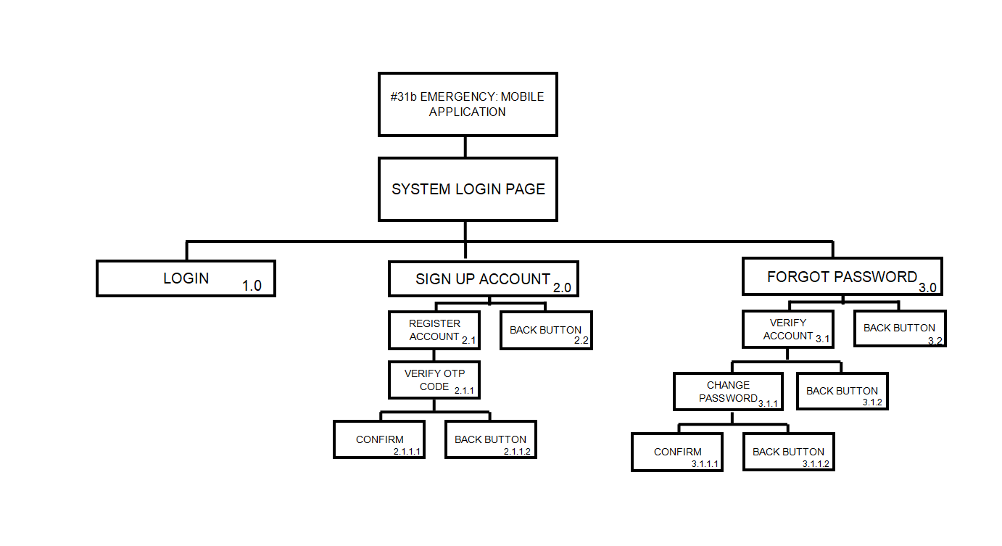

**Landing (Dashboard) Page**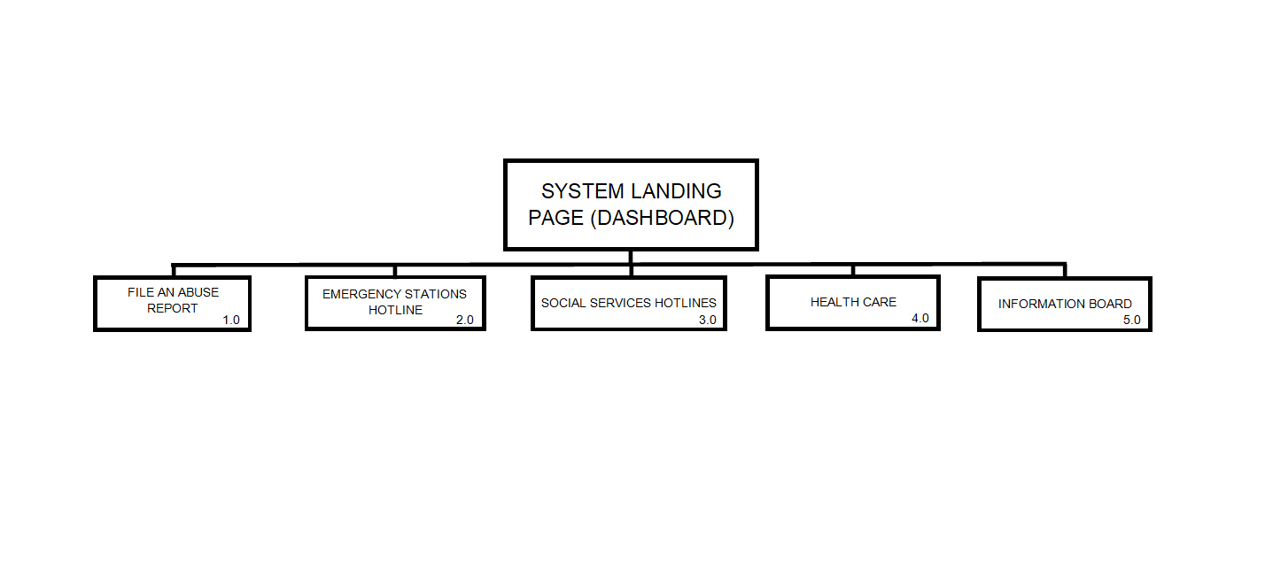

**File an Abuse Report Page**

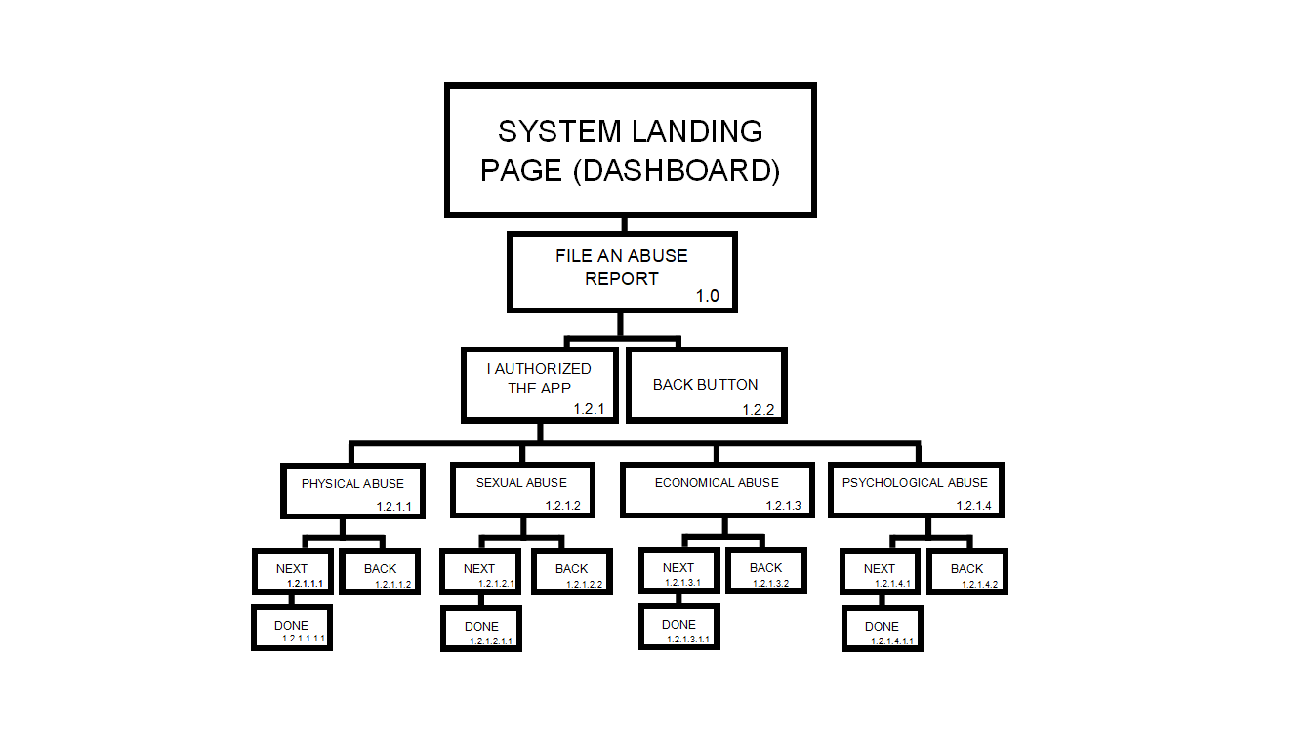

**Emergency Stations Hotlines Page**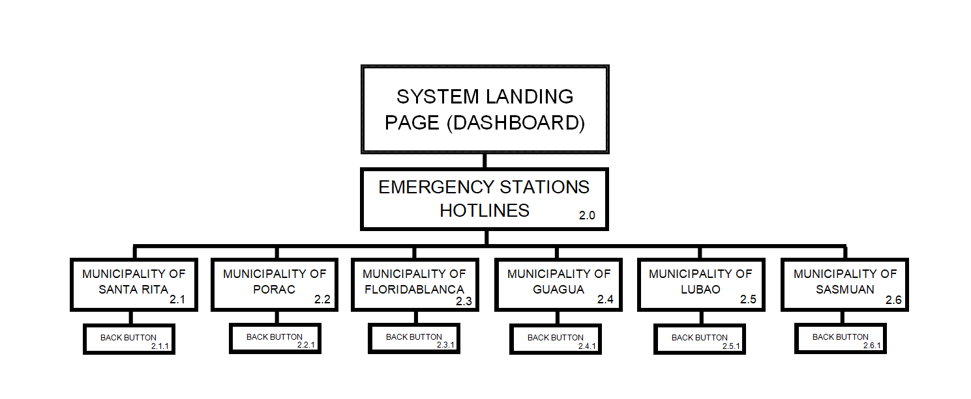

***Insert Here Yung UPDATED Na Social Services

**Social Services Hotlines Page**

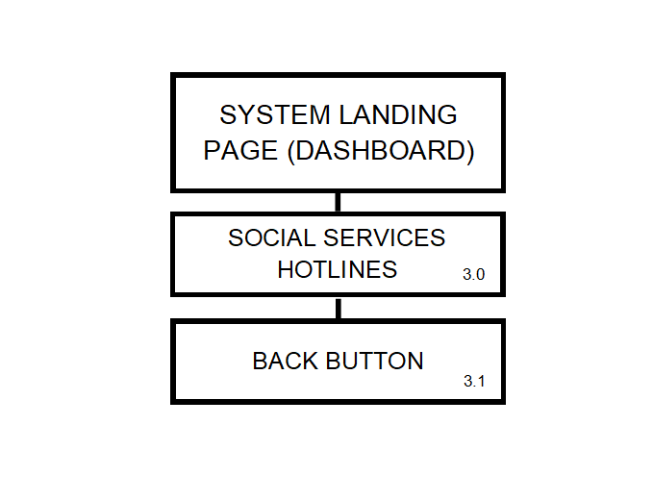

**Health Care Page**

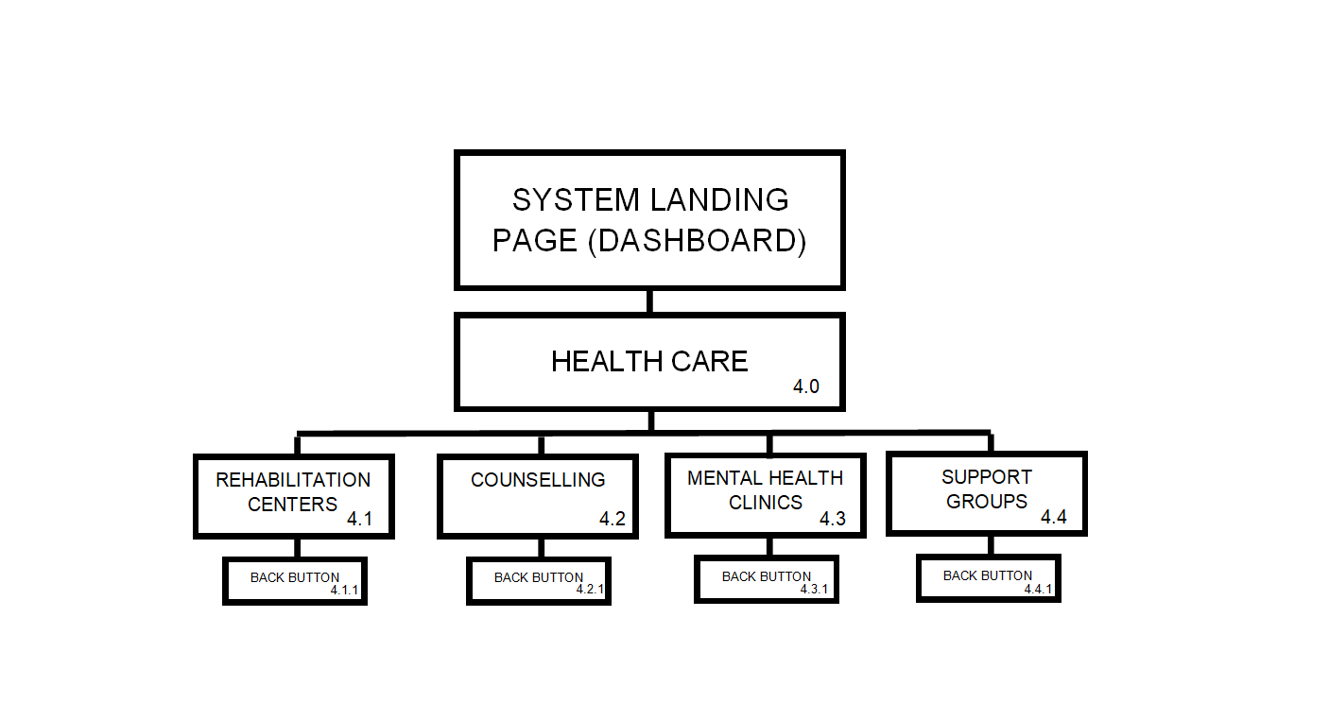

**Information Board Page**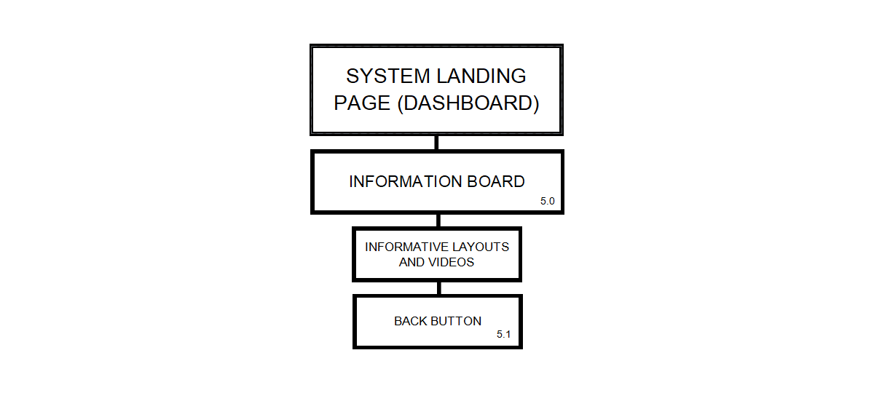

**(User) Side Navigation Panel**

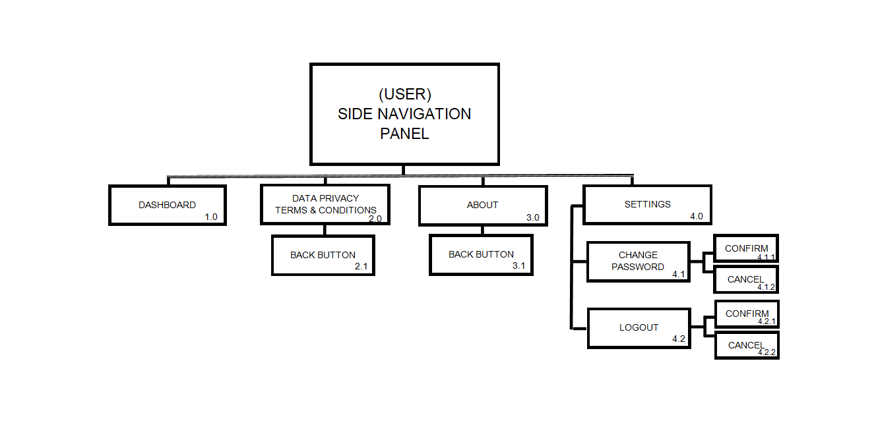

**APPENDIX B**

(Data Flow Diagram and Context Diagram)

**DFD Level 0**

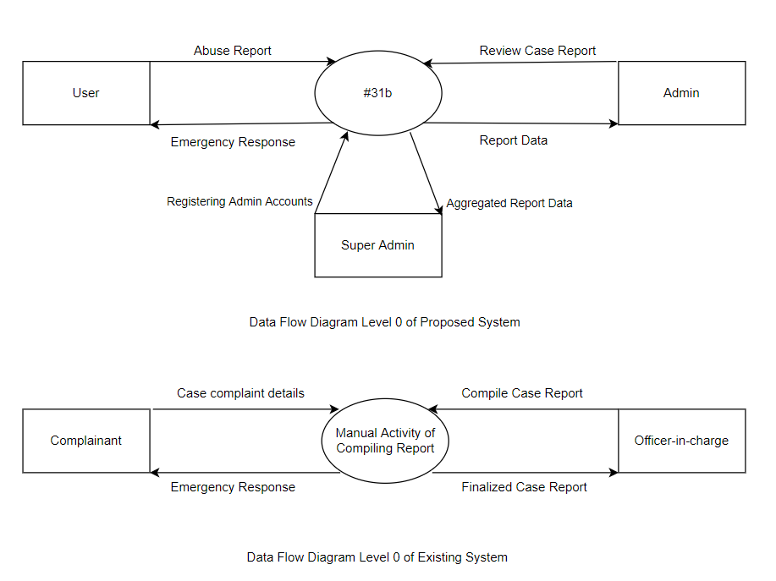



**Context Diagram**

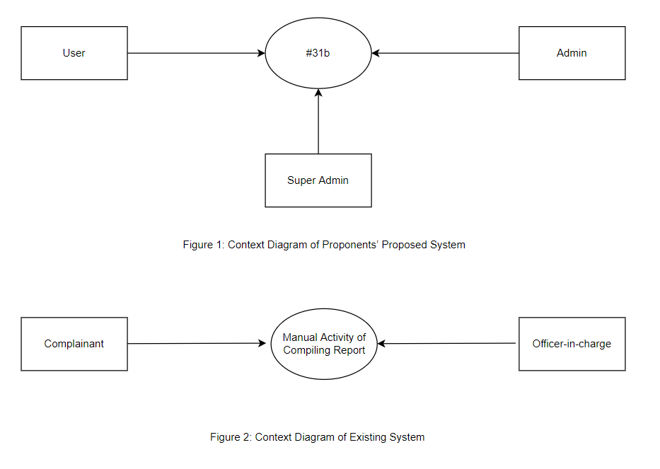

Context Diagram of Proposed System



Context Diagram of Existing System

**APPENDIX C**

(Entity Relationship Diagram)

**Entity Relationship Diagram**

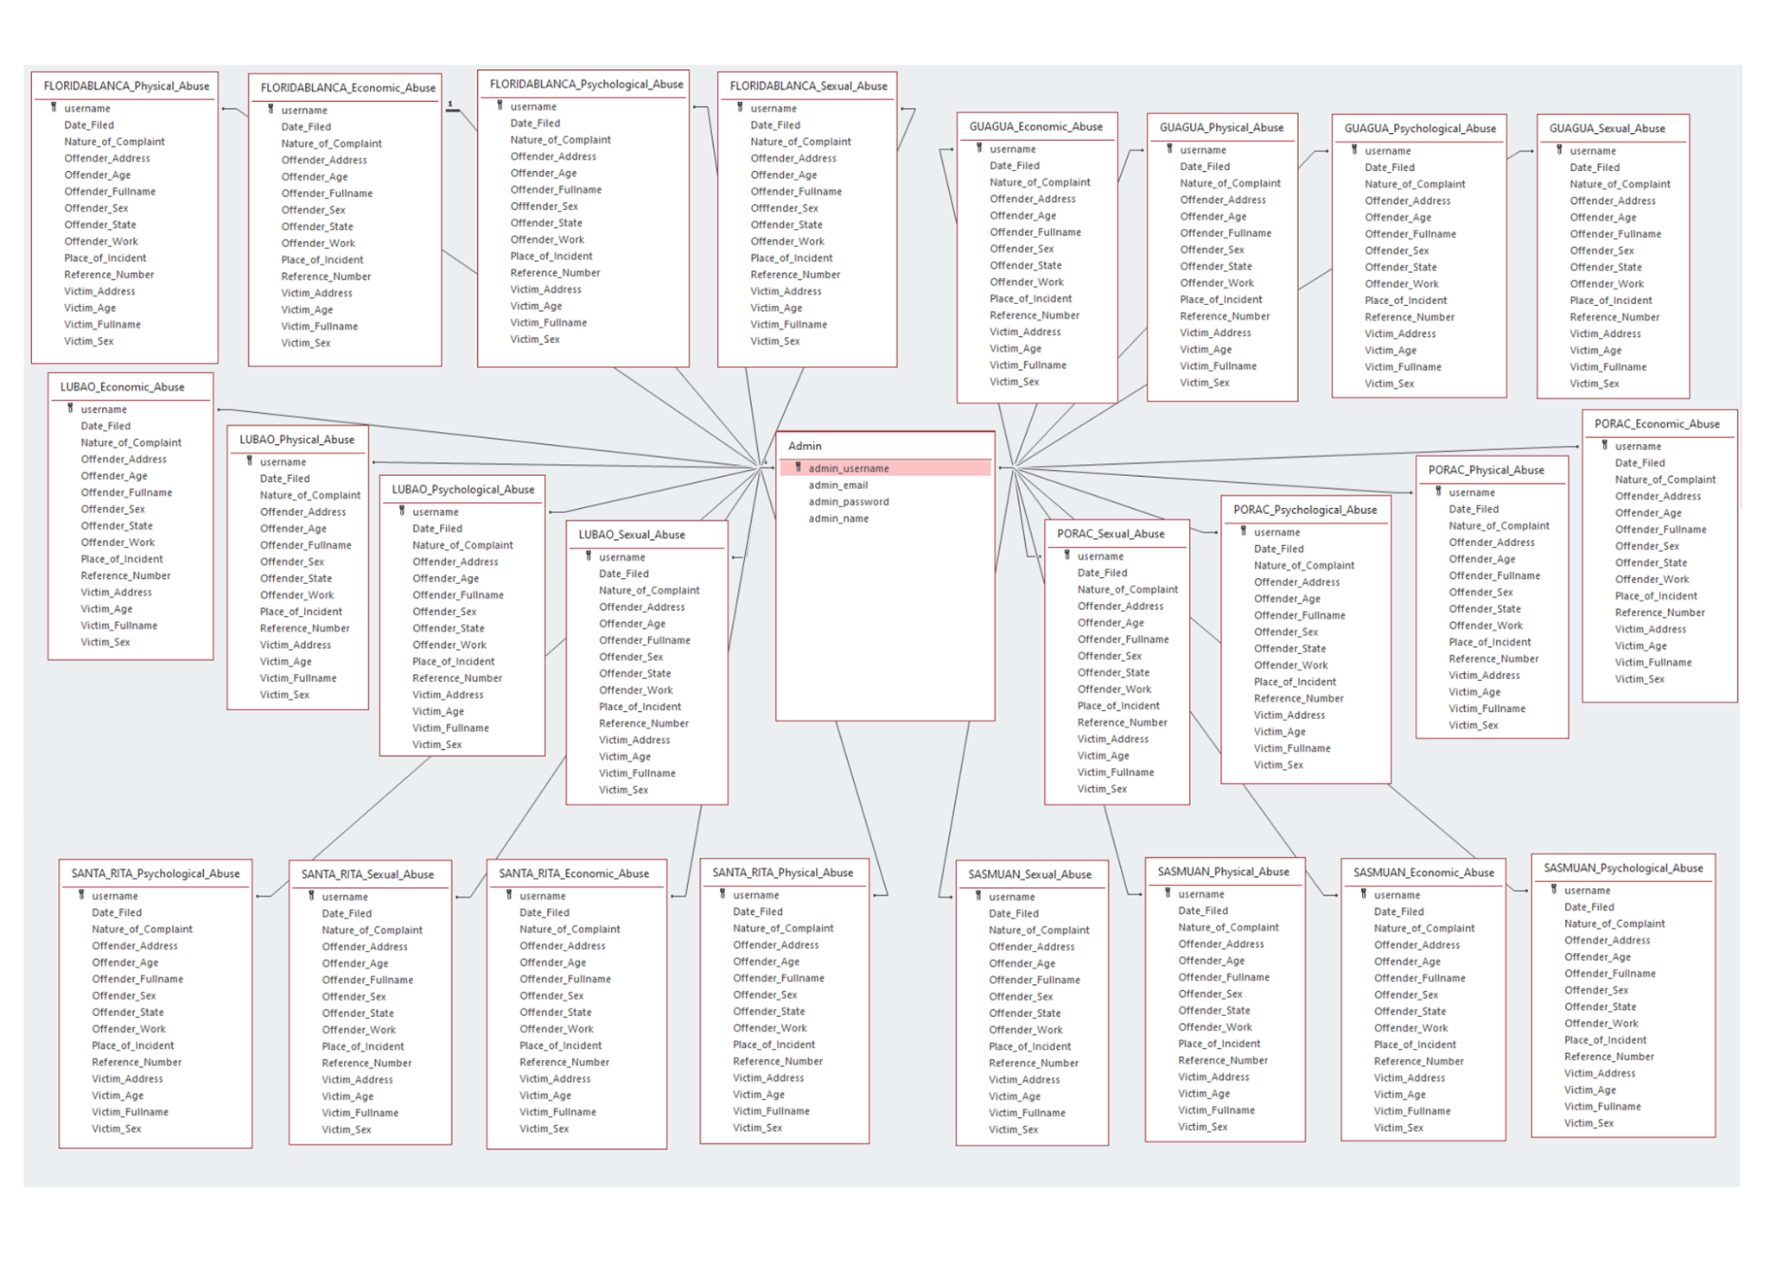

**ERD of #31b Mobile Application (Admin)**

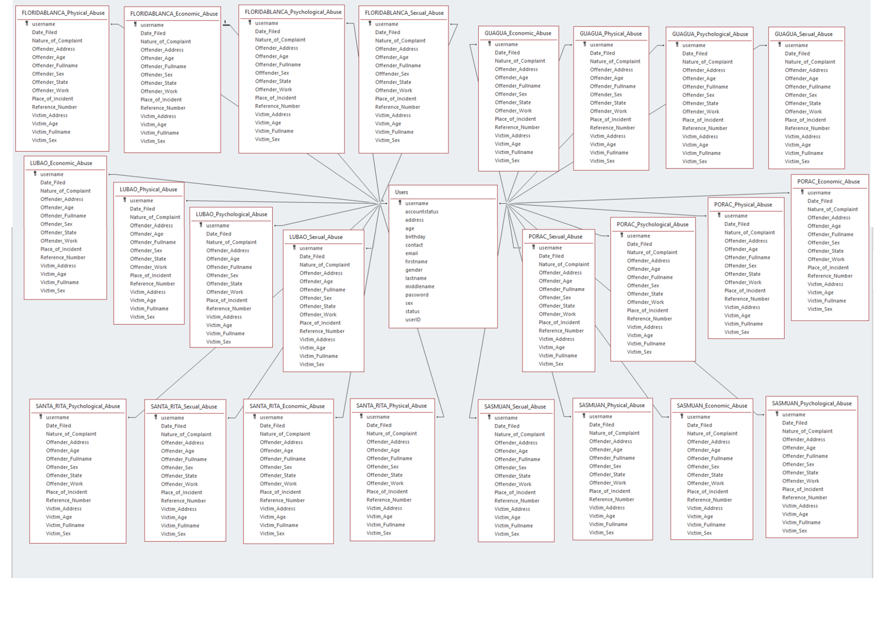

**ERD of #31b Mobile Application (User)**

**APPENDIX D**

(System Flowchart)

**System Flowchart of Proposed System**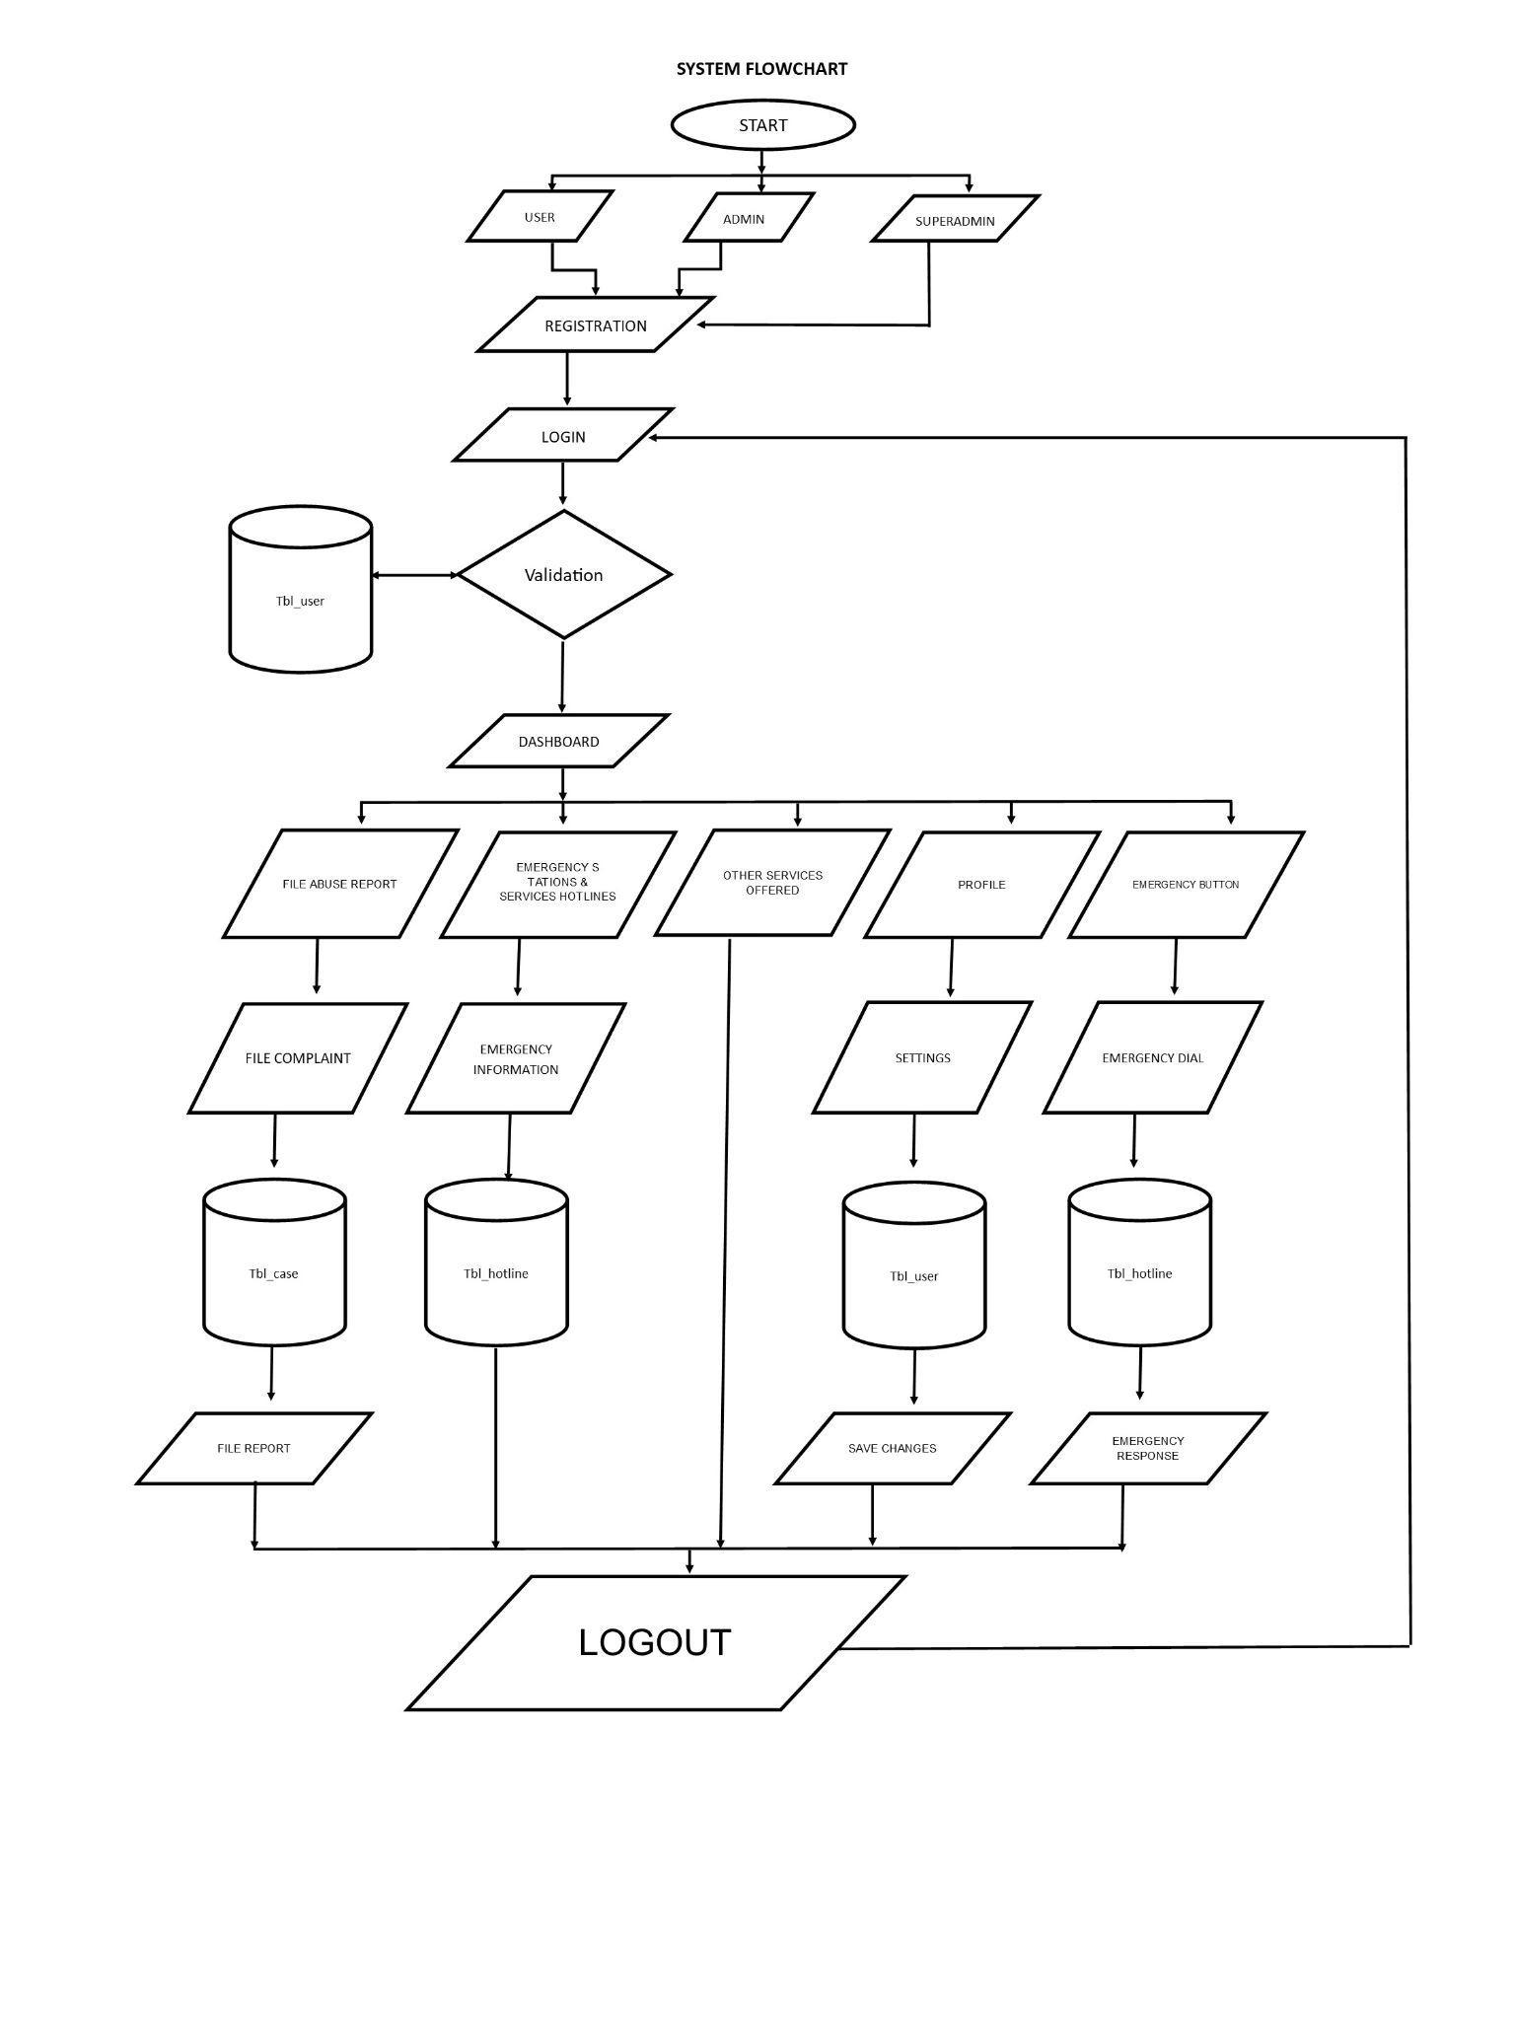

**Existing System Flowchart**

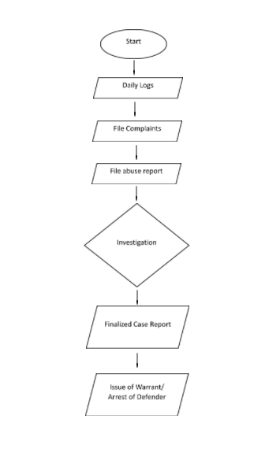

**APPENDIX E**

(Program Flowchart)

**Existing Program Flowchart**

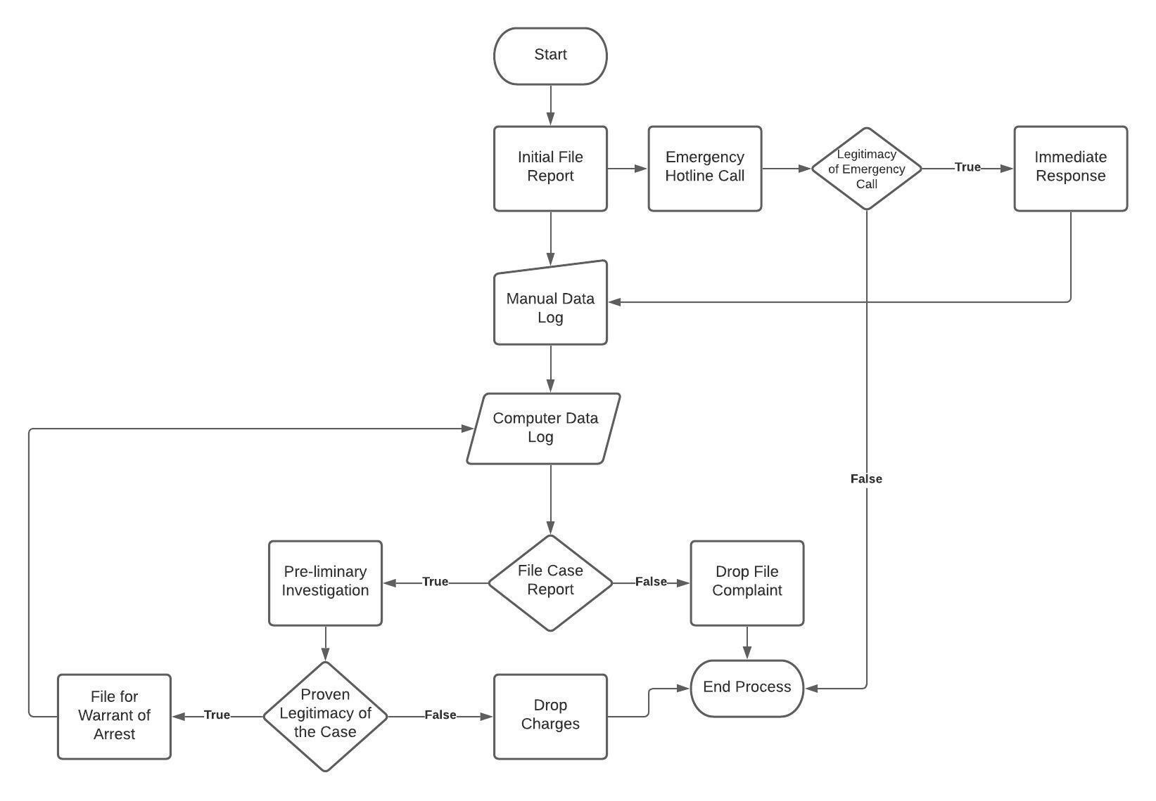

**Proposed System Program Flowchart**

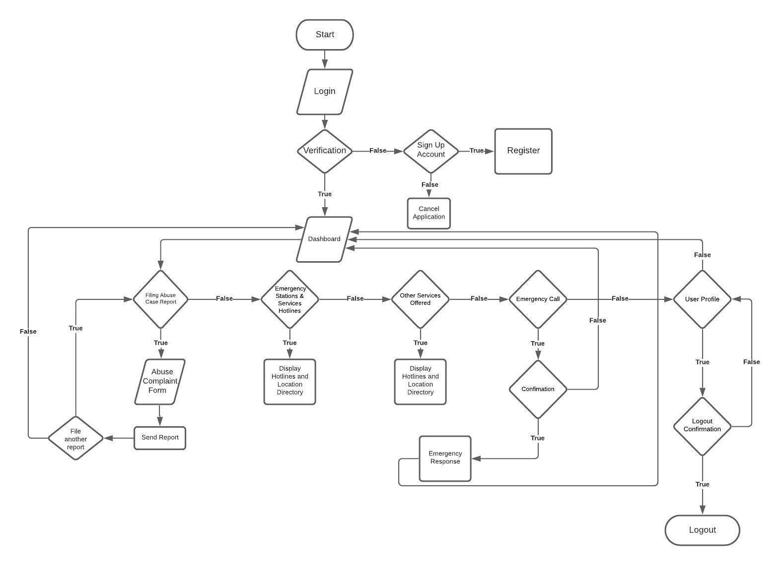

**APPENDIX F**

(Figures)

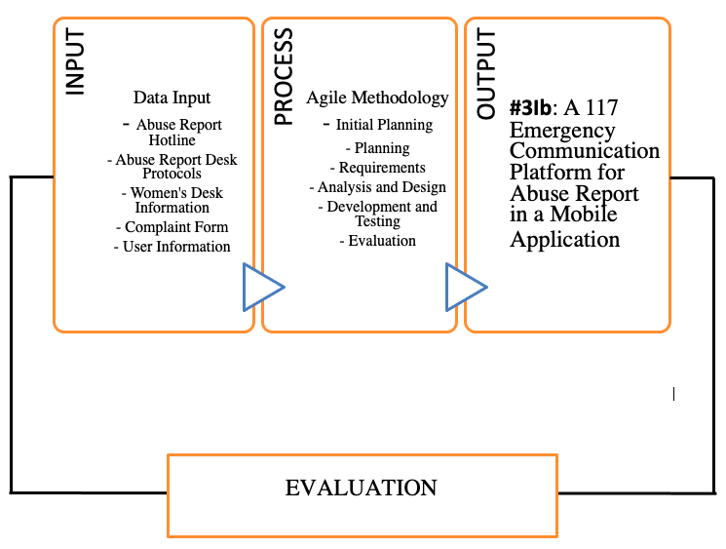

*Figure 1. Conceptual Framework*



*Figure 2 Agile Systems Methodology*



*Figure 3.  Types of Residents*



*Figure 4.  Age of Pampanga Residents*



*Figure 5.  Age of Victim or Witness*****

*Figure 6  Police Respondents*



*Figure 7.  Pampanga Resident Survey question number 1 Results*



*Figure 8. Pampanga Resident Survey question number 1.1 Results*

**

*Figure 9.  Pampanga Resident Survey question number 2 Results*



*Figure 10.  Pampanga Resident Survey question number 3 Results*



*Figure 11. Pampanga Resident Survey question number 4,5,6,7 and 8 Results*

**

*Figure 12.  Pampanga Resident Survey question number 8.1 Results*



*Figure 13 Victim or Witness Survey question number 1 Results*



*Figure 14. Victim/Witness Survey question number 2 Results*



*Figure 15. Victim or Witness Survey question number 2,3,4 Results*



*Figure 16. Victim/Witness Survey question number 5 Results*



*Figure 17. Victim or Witness Survey question number 6 Results*



*Figure 18. Victim/Witness Survey question number 6.1 Results*



*Figure 19. Police Survey question number 1 Results*



*Figure 20. Police Survey question number 2 Results*



*Figure 21. Police Survey question number 3 Results*



*Figure 22. Police Survey question number 4 Results*



*Figure 23. Police Survey question number 5 Results*

**APPENDIX G**

(Tables)

*Table 1.: Likert Four-Point Scale Interpretation*

| **POINT** | **SCALE RANGE** | **INTERPRETATION** |
| --- | --- | --- |
| 4 | 3.26 - 4.00 | Strongly Agree |
| 3 | 2.51 - 3.25 | Agree |
| 2 | 1.76 - 2.50 | Disagree |
| 1 | 1.00 - 1.75 | Strongly Disagree |

*Table 2.: Development Hardware Specifications*

| **HARDWARE SPECIFICATIONS** | |
| --- | --- |
| **Item (Laptop)** | **Specifications** |
| Processor | Intel® Core™ i5-8300H 2.30GHz |
| Memory | 20480MB DDR4 SDRAM |
| Disk Space | 240GB SSD, 1TB HDD |
| Graphics | Nvidia GTX 1050 Ti 4GB |
|  | |
| **Item (Android Phone)** | **Specifications** |
| Processor | MediaTek Helio G85 Octa-core |
| Memory | 6GB RAM |
| Disk Space | 128GB ROM |
| Graphics | Mali-G52 MC2 |

*Table 3. Development Software Specifications*

| **SOFTWARE SPECIFICATIONS** | | |
| --- | --- | --- |
| **Item (Laptop)** | **Name** | **Version** |
| Operating System | Microsoft Windows | 10 |
| Integrated Development Environment (IDE) | Android Studio  Visual Studio Code | 4.2.1  1.62.1 |
| Open-source cross-platform web server | XAMPP | 8.0.12 |
| Database | Firebase Realtime Database | 2021 |
| Cloud Communication Platform | Sinch | 2021 |
|  | | |
| **Item (Android Phone)** | **Name** | **Version** |
| Operating System | Android 11 XOS | 7.6 |

**Table 4. Evaluation of the Functional Stability of the Existing System.**

| **Indicators** | **4** | **3** | **2** | **1** | **WV** | **WM** | **I** |
| --- | --- | --- | --- | --- | --- | --- | --- |
| **Completeness**  The set of functions covers all the specified tasks and user objectives | **18**  (72) | **165**  (495) | **174**  (348) | **20**  (20) | **377**  **(935)** | **2.48** | **Disagree** |
| **Correctness**  The function provides the correct results with the needed degree of precision | **46**  (184) | **142**  (426) | **151**  (302) | **38**  (38) | **377**  **(950)** | **2.52** | **Agree** |
| **Appropriateness**  The function facilitate**s** the accomplishment of specified tasks and objectives | **38**  (152) | **173**  (519) | **124**  (248) | **42**  (42) | **377**  **(961)** | **2.55** | **Agree** |
| **Average Weighted Mean = 2.52 (Agree)** | | | | | | | |

**Table 5. Evaluation of the Reliability of the Existing System**

| **Indicators** | **4** | **3** | **2** | **1** | **WV** | **WM** | **I** |
| --- | --- | --- | --- | --- | --- | --- | --- |
| **Maturity**  The   system meets for reliability under normal operation | **32**  (128) | **134**  (402) | **126**  (252) | **85**  (85) | **377**  **(867)** | **2.30** | **Disagree** |
| **Availability**  The   system is operational and accessible when require for use | **49**  (196) | **144**  (432) | **147**  (294) | **37**  (37) | **377**  **(959)** | **2.54** | **Agree** |
| **Average Weighted Mean = 2.42 (Disagree)** | | | | | | | |

**Table 6.   Evaluation of the Usability of the Existing System**

| **Indicators** | **4** | **3** | **2** | **1** | **WV** | **WM** | **I** |
| --- | --- | --- | --- | --- | --- | --- | --- |
| **Appropriateness Recognizability**  User can recognize whether the   system is appropriate for their needs | **46**  (184) | **149**  (447) | **139**  (278) | **43**  (43) | **377**  **(952)** | **2.53** | **Agree** |
| **Operability**  The   system is easy to operate, control and appropriate to use | **42**  (168) | **465**  (495) | **125**  (250) | **77**  (77) | **377**  **(990)** | **2.63** | **Agree** |
| **User Interface Aesthetics**  A user interface enables pleasing and satisfying interactions for the user | **48**  (192) | **155**  (465) | **112**  (224) | **62**  (62) | **377**  **(943)** | **2.50** | **Disagree** |
| **Accessibility**  The   system can be used by people with the widest range of characteristics and capabilities to achieve a specified goal in a specified context of use. | **43**  (172) | **116**  (348) | **166**  (332) | **52**  (52) | **377**  **(904)** | **2.40** | **Disagree** |
| **Average Weighted Mean = 2.52 (Agree)** | | | | | | | |

**Table 7. Evaluation of the Performance Efficiency of the Existing System**

| **Indicators** | **4** | **3** | **2** | **1** | **WV** | **WM** | **I** |
| --- | --- | --- | --- | --- | --- | --- | --- |
| **Time- behavior**  The response and processing times and throughout rates of the   system, when performing its functions meets the requirements | **39**  (156) | **166**  (498) | **109**  (218) | **63**  (63) | **377**  (935) | **2.48** | **Disagree** |
| **Average Weighted Mean = 2.48 (Disagree)** | | | | | | | |

**Table 8.  Evaluation of the Security of the Existing System**

| **Indicators** | **4** | **3** | **2** | **1** | **WV** | **WM** | **I** |
| --- | --- | --- | --- | --- | --- | --- | --- |
| **Confidentiality**  The   system ensures that data are accessible only to those authorized to have access | **71**  (284) | **154**  (441) | **114**  (228) | **45**  (45) | **377**  **(998)** | **2.65** | **Agree** |
| **Integrity**  The   system prevents unauthorized access to, or modification of, computer programs or data | **74**  (296) | **161**  (483) | **79**  (158) | **63**  (63) | **377**  **(1000)** | **2.65** | **Agree** |
| **Average Weighted Mean = 2.65 (Agree)** | | | | | | | |

**Table 9.  Evaluation of the Functional Stability of the Proposed System**

| **Indicators** | **4** | **3** | **2** | **1** | **WV** | **WM** | **I** |
| --- | --- | --- | --- | --- | --- | --- | --- |
| **Completeness**  The set of functions covers all the specified tasks and user objectives | **275**  (1100) | **102**  (306) | **0** | **0** | **377**  **(1406)** | **3.73** | **Strongly Agree** |
| **Correctness**  The function provides the correct results with the needed degree of precision | **262**  (1048) | **115**  (345) | **0** | **0** | **377**  **(1393)** | **3.69** | **Strongly Agree** |
| **Appropriateness**  The function facilitate**s** the accomplishment of specified tasks and objectives | **277**  (1108) | **98**  (294) | **0** | **0** | **377**  **(1402)** | **3.72** | **Strongly Agree** |
| **Average Weighted Mean = 3.71 (Strongly Agree)** | | | | | | | |

**Table 10. Evaluation of the Reliability of the Proposed System**

| **Indicators** | **4** | **3** | **2** | **1** | **WV** | **WM** | **I** |
| --- | --- | --- | --- | --- | --- | --- | --- |
| **Maturity**  The system meets for reliability under normal operation | **252**  (1004) | **117**  (351) | **9**  (18) | **0** | **377**  **(1373)** | **3.64** | **Strongly Agree** |
| **Availability**  The   system is operational and accessible when require for use | **280**  (1120) | **93**  (279) | **4**  (8) | **0** | **377**  **(1407)** | **3.73** | **Strongly Agree** |
| **Average Weighted Mean = 3.69 (Strongly Agree)** | | | | | | | |

**Table 11.  Evaluation of the Usability of the Proposed System**

| **Indicators** | **4** | **3** | **2** | **1** | **WV** | **WM** | **I** |
| --- | --- | --- | --- | --- | --- | --- | --- |
| **Appropriateness Recognizability**  User can recognize whether the   system is appropriate for their needs | **284**  (1132) | **90**  (270) | **4**  (8) | **0** | **377**  **(1407)** | **3.73** | **Strongly Agree** |
| **Operability**  The   system is easy to operate, control and appropriate to use | **298**  (1192) | **79**  (237) | **0** | **0** | **377**  **(1429)** | **3.79** | **Strongly Agree** |
| **User Interface Aesthetics**  A user interface enables pleasing and satisfying interactions for the user | **314**  (1256) | **62**  (186) | **0** | **0** | **377**  **(1442)** | **3.82** | **Strongly Agree** |
| **Accessibility**  The   system can be used by people with the widest range of characteristics and capabilities to achieve a specified goal in a specified context of use. | **280**  (1120) | **92**  (276) | **5**  (10) | **0** | **377**  **(1406)** | **3.73** | **Strongly Agree** |
| **Average Weighted Mean = 3.77 (Strongly Agree)** | | | | | | | |

**Table 12. Evaluation of the Performance Efficiency of the Proposed System**

| **Indicators** | **4** | **3** | **2** | **1** | **WV** | **WM** | **I** |
| --- | --- | --- | --- | --- | --- | --- | --- |
| **Time- behavior**  The response and processing times and throughout rates of the   system, when performing its functions meets the requirements | **273**  (1092) | **97**  (291) | **7**  (14) | **0** | **377**  **(1397)** | **3.70** | **Strongly Agree** |
| **Average Weighted Mean = 3.70 (Strongly Agree)** | | | | | | | |

**Table 13.  Evaluation of the Security of the Proposed System**

| **Indicators** | **4** | **3** | **2** | **1** | **WV** | **WM** | **I** |
| --- | --- | --- | --- | --- | --- | --- | --- |
| **Confidentiality**  The   system ensures that data are accessible only to those authorized to have access | **308**  **(1228)** | **64**  **(192)** | **6**  **(12)** | **0** | **377 (1432)** | **3.79** | **Strongly Agree** |
| **Integrity**  The   system prevents unauthorized access to, or modification of, computer programs or data | **286(1144)** | **87**  **(261)** | **4**  **(8)** | **0** | **377**  **(1413)** | **3.74** | **Strongly Agree** |
| **Average Weighted Mean = 3.77 (Strongly Agree)** | | | | | | | |

**Table 14.  Proposed System Testing Result Summary**

|  | **Existing System** | | **Proposed System** | |
| --- | --- | --- | --- | --- |
| **Indicators** | **Mean** | **Interpretation** | **Mean** | **Interpretation** |
| Functional Stability | 2.52 | Agree | 3.71 | Strongly Agree |
| Reliability | 2.42 | Disagree | 3.69 | Strongly Agree |
| Usability | 2.52 | Agree | 3.77 | Strongly Agree |
| Performance Efficiency | 2.48 | Disagree | 3.70 | Strongly Agree |
| Security | 2.65 | Agree | 3.77 | Strongly Agree |
| **AVERAGE MEAN** | **2.52** | **Agree** | **3.73** | **Strongly Agree** |

**APPENDIX H**

(Survey Questionnaires)

PRE-STUDY SURVEY QUESTIONNAIRE ( FOR VICTIM / WITNESS)

Overview of the Study

The researchers reconstructed and validated a simple questionnaire to be completed by respondents age 13 and above. All responses will be kept confidential and combined with other responses when reporting the result. We certainly would like to request your full cooperation and honest feedback.

Name (Optional): ___________________________________________ Date: ______________

Age: ______________ Gender: ○Female ○Male ○Prefer not to say

Municipality:

* Guagua
* Porac
* Lubao
* Santa Rita
* Floridablanca
* Sasmuan

Barangay: _____________________________________

Educational Attainment:

* Elementary
* Junior High School
* Senior High School
* Undergraduate
* Bachelor’s Degree
* Master’s Degree
* Doctorate Degree

**4 - Strongly Agree 3 -Agree 2 - Disagree 1 - Strongly Disagree**

| **SURVEY QUESTIONS** | **4** | **3** | **2** | **1** |
| --- | --- | --- | --- | --- |
| 1.) The available emergency hotlines or complaint forms for reporting or filing any abuse cases are easy to find and use.  *(Ang mga maaaring tawagan na emergency hotlines o mga complaint forms upang makapaghain ng reklamo ng pang-aabuso ay madaling mahanap at gamitin.)* |  |  |  |  |
| 1.1)The highly acknowledged type of media to boost the abuse awareness is through:  (Ang mga pinakakilala na uri ng midya na naglalayong mabigyan ng kamalayan ang pang-aabuso ay sa pamamagitan ng sumusunod:) | | | | |
| * television (telebisyon) |  |  |  |  |
| * social media (sosyal medya) |  |  |  |  |
| * police stations (istasyon ng mga pulis) |  |  |  |  |
| 1.2) I feel more protected and well-assisted when I use the available hotlines to report my abuse case or experience..  *(Mas ramdam ko na ako ay protektado at lubos na natutulungan sa tuwing nakakagamit ako ng mga maaring tawagan para iulat ang mga karanasan o pangyayaring pang-aabuso)* |  |  |  |  |
| 1.3) The hotlines are effective in minimizing cases of abuse.  *(Ang mga numerong maaring tawagan ay epektibo sa pagpapababa ng mga bilang ng kaso sa pang-aabuso)* |  |  |  |  |
| 1.4) The hotlines are accessible to victims or complainants.  *(Ang mga numerong maaring tawagan ay madaling makukuha ng mga biktima o nag-uulat ng reklamo.)* |  |  |  |  |
| 2.)The hotlines are active in accommodating abuse filing reports or emergency cases.  *(Ang mga ibinigay na ‘hotlines’ ay aktibo anumang oras at mabilis rumesponde sa mga kaso or sumbong ng pang aabuso)* |  |  |  |  |
| 3.) I did not report an abuse (experienced or witnessed) because I feel scared, unprotected and uncomfortable reporting it via phone call or in a written complaint form.  *(Hindi ako nag-uulat ng pang-aabuso (biktima*  *man o saksi) dahil nakakaramdam ako ng takot,*  *hindi ako protektado at komportable na iulat ito*  *gamit ang telepono o kahit na sa paraang*  *pasulat.)* |  |  |  |  |
| 4.) The emergency response team gave a full response and accommodated the complaint very well.  *(Ang mga grupo ng mga tumutugon sa oras ng pangangailangan ay nagbibigay ng buong aksyon at tinatanggap ng napakahusay ang reklamo.)* |  |  |  |  |
| 5.) I became more aware of the abuse cases / reports, emergency hotline or services in our place using…  *(Ako ay mas naging maalam sa mga balita/kaso ng pang-aabuso, at mga numero ng pangangailangan at serbisyo sa aming lugar gamit ang mga sumusunod:)* | | | | |
| * Social Media |  |  |  |  |
| * Application Advertisement (Ads) *(pang-aplikasyon anunsyo)* |  |  |  |  |
| * Landline / Mobile phone *(‘landline’ o numero ng telepono)* |  |  |  |  |
| * Text Messages or E-mail (‘*tekstong mensahe o elektronikong mensahe)* |  |  |  |  |
| * Electronic Form (Google Form) *(elektronikong ‘forms’)* |  |  |  |  |
| * Leaflet / Flyers / Tarpaulin *(polyeto)* |  |  |  |  |
| * Newspaper *(dyaryo)* |  |  |  |  |
| 6.) I am interested in an application developed for abuse incident reports and would deliver a more convenient way for the users.  *(Ako ay interasado sa isang aplikasyon na binuo para sa pag-uulat ng mga kaso ng pang-aabuso, at para maghatid ng mas maginhawang paraan sa mga gagamit.)* |  |  |  |  |
| 6.1.) I feel like it is easier to use the emergency application via…  *(Sa aking pakiramdam o palagay ay mas*  *madaling gamitin ang emergency application*  *gamit ang mga sumusunod)* |  |  |  |  |
| * Mobile Application |  |  |  |  |
| * Web Application |  |  |  |  |
| * Installed Software |  |  |  |  |

( ) I hereby give my full consent to the Don Honorio Ventura State University (DHVSU) researchers of this survey, to collect and process my personal information and survey response. I understand that this pre-study survey is strictly monitored and protected by the Data Privacy Act of 2012.

( ) Ibinibigay ko ang aking buong pahintulot sa mga mag-aaral ng Don Honorio Ventura State University (DHVSU) na nagsasaliksik, at maaring kolektahin at i-proseso ang aking mga personal na impormasyon at kasagutan sa kanilang katanungan. Nauunawaan ko na ang *Pre-Study Survey* na ito ay mahigpit na tumutugon at pinoprotektahan ayon sa *Data Privacy Act of 2012.*

PRE-STUDY SURVEY QUESTIONNAIRE (FOR POLICE)

Overview of the Study

The researchers reconstructed and validated a simple questionnaire to be completed by the police respondents. All responses will be kept confidential and combined with other responses when reporting the result. We certainly would like to request your full cooperation and honest feedback.

Name (Optional): ___________________________________________ Date: ______________

Age: ______________ Sex: ○Female ○Male

Police Officer Rank & Division:__________________________________________

Assigned Police Stations:

○Sta. Rita Municipal Police Station ○Porac Municipal Police Station

○Guagua Municipal Police Station ○Floridablanca Municipal Police Station

○Lubao Municipal Police Station ○Sasmuan Municipal Police Station

**4 - Very Frequently 3 - Frequently 2 - Rarely 1 - Very Rarely**

| **SURVEY QUESTIONS** | **4** | **3** | **2** | **1** |
| --- | --- | --- | --- | --- |
| 1.) How often do the police receive complaints or emergency calls regarding abuse? |  |  |  |  |
| 2.) In what way do Police stations receive Complaints? | | | | |
| * Phone Calls |  |  |  |  |
| * Personal / Physical Report |  |  |  |  |
| * Social Media |  |  |  |  |
| * Written Form |  |  |  |  |
| 3.) What is the most convenient way of receiving a report? | | | | |
| * Face-to-Face |  |  |  |  |
| * Emergency Hotline |  |  |  |  |
| * Text Message |  |  |  |  |
| * Through Television/ Radio |  |  |  |  |
| 4.) What platform do you use to spread campaigns and spread awareness against violence and abuse? |  |  |  |  |
| * Social Media |  |  |  |  |
| * Television |  |  |  |  |
| * Radio Stations |  |  |  |  |
| * Flyers / Tarpaulins |  |  |  |  |
| * Others, pls specify: __________ |  |  |  |  |
| 5.) I am willing to use a platform or an application that can receive and process abuse reports. |  |  |  |  |

( ) I hereby give my full consent to the Don Honorio Ventura State University (DHVSU) researchers of this survey, to collect and process my personal information and survey response. I understand that this pre-study survey is strictly monitored and protected by the Data Privacy Act of 2012.

( ) Ibinibigay ko ang aking buong pahintulot sa mga mag-aaral ng Don Honorio Ventura State University (DHVSU) na nagsasaliksik, at maaring kolektahin at i-proseso ang aking mga personal na impormasyon at kasagutan sa kanilang katanungan. Nauunawaan ko na ang *Pre-Study Survey* na ito ay mahigpit na tumutugon at pinoprotektahan ayon sa *Data Privacy Act of 2012.*

PRE-STUDY SURVEY QUESTIONNAIRE (ORDINARY RESIDENT)

Overview of the Study

The researchers reconstructed and validated a simple questionnaire to be completed by respondents age 13 and above. All responses will be kept confidential and combined with other responses when reporting the result. We certainly would like to request your full cooperation and honest feedback.

*(Sa kabuuan ng Pag-aaral)*

*(Ang mga mananaliksik muling buuin at pinapatunayan ang mga simpleng katanungan na sasagutin ng mga kasangkot mula edad 13 hanggang pataas. Ang lahat ng mga tugon ay pananatilihing kumpidensyal at isasama sa iba pang mga tugon kapag ini-uulat ang resulta. Ninanais din ng mga mananaliksik na hilingin at hingian ang iyong buong kooperasyon at tapat na pagsagot.)*

Name (Optional): ___________________________________________ Date: ______________

Age: ______________ Gender: ○Female ○Male ○Prefer not to say

Municipality:

* Guagua
* Porac
* Lubao
* Santa Rita
* Floridablanca
* Sasmuan

Barangay: _____________________________________

Educational Attainment:

* Elementary
* Junior High School
* Senior High School
* Undergraduate
* Bachelor’s Degree
* Doctorate

**4 - Strongly Agree 3 -Agree 2 - Disagree 1 - Strongly Disagree**

| **SURVEY QUESTIONS** | **4** | **3** | **2** | **1** |
| --- | --- | --- | --- | --- |
| 1.) The available emergency hotlines or complaint forms for reporting or filing any abuse cases are easy to find and use.  *(Ang mga emergency hotlines o mga forms ay madaling gamitin at mahanap.)* |  |  |  |  |
| 1.1) I often see or hear informations about the hotlines from: *(Aking kadalasang nakikita o naririnig ang mga ‘hotlines’ sa pamamagitan ng..)* | | | | |
| * television *(telebisyon)* |  |  |  |  |
| * social media |  |  |  |  |
| * police stations *(istasyon ng mga pulis)* |  |  |  |  |
| * radio *(radyo)* |  |  |  |  |
| * newspaper *(dyaryo)* |  |  |  |  |
| 2.) I think the hotlines are active for accommodating abuse filing reports or emergency cases.  *(Sa aking palagay ang mga numero o hotlines ay aktibo na tumatanggap ng tugon sa mga nag uulat ng kaso sa pang-aabuso.)* |  |  |  |  |
| 3.) I became more aware of the abuse cases / reports, emergency hotline or services in our place using…  *(Ako ay mas naging maalam sa mga balita/kaso ng pang-aabuso, at mga numero ng pangangailangan at serbisyo sa aming lugar gamit ang mga sumusunod:)* | | | | |
| * Social Media |  |  |  |  |
| * Application Advertisement (Ads) *(pang-aplikasyon anunsyo)* |  |  |  |  |
| * Landline / Mobile phone *(‘landline’ o numero ng telepono)* |  |  |  |  |
| * Text Messages or E-mail (‘*tekstong mensahe o elektronikong mensahe)* |  |  |  |  |
| * Electronic Form (Google Form) *(elektronikong ‘forms’)* |  |  |  |  |
| * Leaflet / Flyers / Tarpaulin *(polyeto)* |  |  |  |  |
| * Newspaper *(dyaryo)* |  |  |  |  |
| 3.) It would be better if there is an application that will give me knowledge and awareness about abuse cases.  *(Mas maganda/mainam kung may application na magbibigay ng kaalaman at kamalayan ukol sa mga kaso ng pang-aabuso.)* |  |  |  |  |
| 4.) It would be better if the application is easy to use and to understand.  *(Mas maganda/mainam kung ang application ay madaling magamit at maintindihan.)* |  |  |  |  |
| 5.) It would be better if there is an application that contains important information about the sectors that are involved in helping abused victims.  *(Mas mainam/maganda kung may application na*  *naglalaman ng mahahalagang impormasyon ukol sa mga taong bahagi ng pagtulong sa mga*  *biktima ng pang-aabuso.)* |  |  |  |  |
| 6.)I am interested in an application developed for abuse incident reports and would deliver a more effective and convenient way for the users.  *(Ako ay interasado sa isang aplikasyon na binuo para sa pag-uulat ng mga kaso ng pang-aabuso, at para maghatid ng mas epektibo at maginhawang paraan sa mga gagamit.)* |  |  |  |  |
| 7.)I look forward to using an application that can provide an emergency communication platform and quick response assistance for any abuse cases.  *(Inaasahan kong magagamit ko ang aplikasyon na magbibigay sa akin ng komunikasyon sa oras ng pangangailan at may bilis sa pagtugon sa pagtulong ng mga kaso ng pang-aabuso.)* |  |  |  |  |
| 7.1.) I feel like it is easier to use the emergency application via…  *(Sa aking pakiramdam o palagay ay mas madaling gamitin ang emergency application gamit ang mga sumusunod)* |  |  |  |  |
| * Mobile Application *(aplikasyon pang ‘mobile’)* |  |  |  |  |
| * Web Application *(aplikasyon pang ‘web’)* |  |  |  |  |
| * Software Installed |  |  |  |  |

( ) I hereby give my full consent to the Don Honorio Ventura State University (DHVSU) researchers of this survey, to collect and process my personal information and survey response. I understand that this pre-study survey is strictly monitored and protected by the Data Privacy Act of 2012.

( ) Ibinibigay ko ang aking buong pahintulot sa mga mag-aaral ng Don Honorio Ventura State University (DHVSU) na nagsasaliksik, at maaring kolektahin at i-proseso ang aking mga personal na impormasyon at kasagutan sa kanilang katanungan. Nauunawaan ko na ang *Pre-Study Survey* na ito ay mahigpit na tumutugon at pinoprotektahan ayon sa *Data Privacy Act of 2012.*

**APPENDIX I**

(Evaluation Tool)

**Evaluation Tools for the Proposed System**

Name: (*Optional)*____________________ Age: _____

Gender: ○Female ○Male ○Prefer not to say

Municipality:

* Guagua
* Porac
* Lubao
* Santa Rita
* Floridablanca
* Sasmuan

Barangay: _____________________________________

Type of Respondent: ○Victim/Witness ○ Police ○Ordinary Resident

Please rate each statement based on your Expectations and opinions of the proposed system by showing the extent to which you think you should possess the following feature. If you strongly disagree on the statement, check 1, if you strongly agree on the statement check 4, if your feeling is less strong check one of the numbers in the middle. There are no right or wrong answers; all we are interested in is the number that truly reflects your feelings about the proposed system.

**LEGEND: 4 –Strongly Agree 3 –Agree 2 – Disagree 1 – Strongly disagree**

1. **Functional Stability**

| **Indicators** | | **4** | **3** | **2** | **1** |
| --- | --- | --- | --- | --- | --- |
| **Completeness** | The set of functions covers all the specified tasks and user objectives |  |  |  |  |
| **Correctness** | The function provides the correct results with the needed degree of precision |  |  |  |  |
| **Appropriateness** | The function facilitate**s** the accomplishment of specified tasks and objectives |  |  |  |  |

1. **Reliability**

| **Indicators** | | **4** | **3** | **2** | **1** |
| --- | --- | --- | --- | --- | --- |
| **Maturity** | The proposed system meets for reliability under normal operation |  |  |  |  |
| **Availability** | The proposed system is operational and accessible when require for use |  |  |  |  |

1. **Usability**

| **Indicators** | | **4** | **3** | **2** | **1** |
| --- | --- | --- | --- | --- | --- |
| **Appropriateness Recognizability** | User can recognize whether the proposed system is appropriate for their needs |  |  |  |  |
| **Operability** | The proposed system is easy to operate, control and appropriate to use |  |  |  |  |
| **User Interface Aesthetics** | A user interface enables pleasing and satisfying interactions for the user |  |  |  |  |
| **Accessibility** | The proposed system can be used by people with the widest range of characteristics and capabilities to achieve a specified goal in a specified context of use. |  |  |  |  |

1. **Performance Efficiency**

| **Indicators** | | **4** | **3** | **2** | **1** |
| --- | --- | --- | --- | --- | --- |
| **Time- behavior** | The response and processing times and throughout rates of the proposed system, when performing its functions meets the requirements |  |  |  |  |
| **Capacity** | The maximum limits of the proposed system parameter meets the requirements |  |  |  |  |

1. **Security**

| **Indicators** | | **4** | **3** | **2** | **1** |
| --- | --- | --- | --- | --- | --- |
| **Confidentiality** | The proposed system ensures that data are accessible only to those authorized to have access |  |  |  |  |
| **Integrity** | The proposed system prevents unauthorized access to, or modification of, computer programs or data |  |  |  |  |